# Introduction

Proteins and Nucleic acids (DNA and RNA) are the fundamental building blocks of all life on earth. The famous “central dogma” of life, proposed by Francis Crick [1](https://paperpile.com/c/7HQKXY/M0eAi) states that there is a sequential flow of information from nucleic acids to proteins, and not backwards. No exceptions to the crick’s definition of central dogma has been observed till date. However, research done before and after the proposal of central dogma has established that this flow of information could be regulated, either through nucleic acids themselves, or through proteins.

A “gene” is the major component of central dogma. The overall definition of a gene has been debated and revised to include protein-coding genes, regulatory elements such as “promoters” and “enhancers”, and regions that produce non-coding RNAs [2](https://paperpile.com/c/7HQKXY/3QS1S) [3](https://paperpile.com/c/7HQKXY/Zooup). A protein-coding gene transfers it’s encoded information into the protein product, through “transcription”, and “translation” (Appendix B). DNA elements that regulate this flow of information (or “expression”), such as promoters or enhancers, are stably inherited through generations and contribute to evolution [4](https://paperpile.com/c/7HQKXY/l02kG). Apart from DNA elements, other factors such as semi-stable modifications to DNA elements (eg. methylation), non-coding RNAs (eg. antisense RNA [5](https://paperpile.com/c/7HQKXY/UpD8U), micro-RNA [6](https://paperpile.com/c/7HQKXY/66Wvh), long non-coding RNA [7](https://paperpile.com/c/7HQKXY/RFgcA) etc.), proteins that interact with DNA (histone marks, transcription factors), and proteins that interact with mRNA [8](https://paperpile.com/c/7HQKXY/H09HK) also regulate gene expression. Many of these gene regulatory mechanisms are established either in response to environmental changes or through genetic programming, and in some cases, could be stably maintained through cell cycle, or across multiple generations. Such mechanisms are collectively studied under the term “epigenetics” [9](https://paperpile.com/c/7HQKXY/gicXl).

In order to understand the regulation of gene expression, it’s important to study how various genetic and epigenetic regulators interact with each other. Advances in next generation sequencing (NGS) [10,11](https://paperpile.com/c/7HQKXY/IFg2j+UaaXw) have allowed us to study these interactions at multiple scales, ranging from local gene neighborhood to overall organisation of a chromosome. In the following sections, I would discuss the various scales of gene regulation, as well as current state of the art techniques to study them.

## Multiple scales of genomic regulation

### Local scale : DNA elements, histone marks and transcription factors

The “selected effect” definition of biological function [12](https://paperpile.com/c/7HQKXY/ML9gI) implies that all functional elements should be under some sort of selective pressure. The primary evolutionary analysis of mammalian genome therefore proposed ~5% of human-mouse genome to be functional [13](https://paperpile.com/c/7HQKXY/lIZg1). This estimate, which was already about 4-times larger than the protein-coding fraction [14](https://paperpile.com/c/7HQKXY/7auK6)), was further expanded in later analysis [15,16](https://paperpile.com/c/7HQKXY/epOGn+fjAZ6). Genome-wide analysis have also proposed “biochemical function” for many new genetic elements [17](https://paperpile.com/c/7HQKXY/mU5yX). Most of these non-coding DNA elements such as promoters, enhancers, silencers, insulators and transposons, have been classically known to be involved in regulation of protein-coding genes [18](https://paperpile.com/c/7HQKXY/Cj5ky) (Table-1).

It has become increasingly clear that DNA elements do not act alone, but rather within the influence of the histone code [19](https://paperpile.com/c/7HQKXY/1exNO). In fact various evidences suggest that gene regulation happens via a cross-talk between transcription factors, DNA elements, DNA modifications (such as methylation) and histone marks. For example, during embryonic development, pluripotency genes Oct3/4 are switched off in a multi-step process where first a repressor binds to it’s promoter, turning off transcription, followed by recruitment of histone methyltransferase and histone deacetylase enzymes leading to transcriptional repression and H3K9 methylation. This follows binding of DNMT3A and DNMT3B methyltransferases, leading to promoter methylation and ultimately gene suppression [20,21](https://paperpile.com/c/7HQKXY/xq96n+xbVfG). Apart from this cross-talk, the physical distance between regulatory elements and their targets also influence gene expression. Chromatin marks such as H3K9 methylation could spread into large domains, while TFs are suggested to induce looping of chromatin in order to achieve spatial proximity to their target genes [22](https://paperpile.com/c/7HQKXY/qjCrb). This looping is regulated via insulators, adding additional layer to gene regulation.

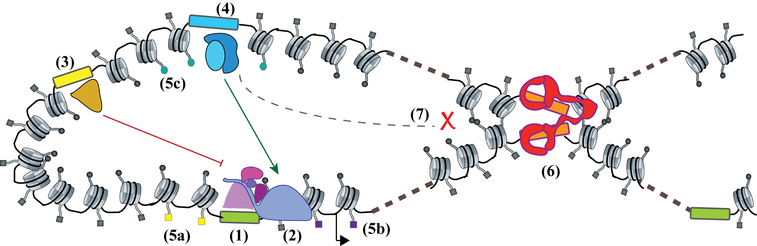

***Fig 1 : Regulation of gene expression by various genetic and epigenetic elements.*** *A promoter (1) recruits RNAP-II (2) to perform transcription of target genes. Elements such as repressors (3) or enhancers (4) could recruit transcription factors that either suppress or activate gene expression. All these elements are marked by various histone marks, such as H3K4me3 at promoters (5a) H3K36me3 at gene bodies (5b) or H3K27ac at enhancers (5c), which facilitate gene expression. Insulators (6) recruit proteins that facilitate DNA looping, and block transcription factors from activating genes outside of the established boundaries (7).*

### Global scale : Loops, TADs, and compartments

Looping of DNA has been shown as the mechanism behind long-range enhancer-promoter interactions in early 1990s [23](https://paperpile.com/c/7HQKXY/uJfV1). Since then, various techniques have been developed to study long-range interactions via chromatin looping (see section on analysis of chromosome conformation). Genome-wide derivation of the chromosome conformation capture (3C) technique, called HiC [24](https://paperpile.com/c/7HQKXY/lrwqn) is currently the most popular amongst those. Early HiC studies were limited by their resolution, and therefore discovered higher-order chromatin structures called compartments [24](https://paperpile.com/c/7HQKXY/lrwqn) and chromatin domains, referred as topological associated domains (TADs) [25](https://paperpile.com/c/7HQKXY/5Lm8o). Later studies revealed that the chromatin is hierarchically organized, where the domains with similar chromatin signature are spatially clustered. At the highest level of clustering, genome can be divided into A and B compartments, which separate inactive and active chromatin in the cell [24](https://paperpile.com/c/7HQKXY/lrwqn). Compartments could further be segregated into subcompartments that represent clustering of histone marks [26](https://paperpile.com/c/7HQKXY/CokeH). TADs serve as the next (lower) level of this segregation, while enhancer-promoter loops are at the lowest level. Functionally, TADs were shown to act as “regulatory units” or “insulated neighbourhoods”, limiting enhancer-promoter interactions and the spread of chromatin marks [27](https://paperpile.com/c/7HQKXY/YDcIe). This property of TADs resembles those of insulators, and in fact several classically studied insulator proteins were found to be associated with TAD boundaries [28](https://paperpile.com/c/7HQKXY/3xOT4). Interestingly, unlike loops, which show cell-type specific interactions [29](https://paperpile.com/c/7HQKXY/XJABO), TADs have been indicated to be cell-type invariant and evolutionarily conserved [25,30](https://paperpile.com/c/7HQKXY/5Lm8o+NkaRy).

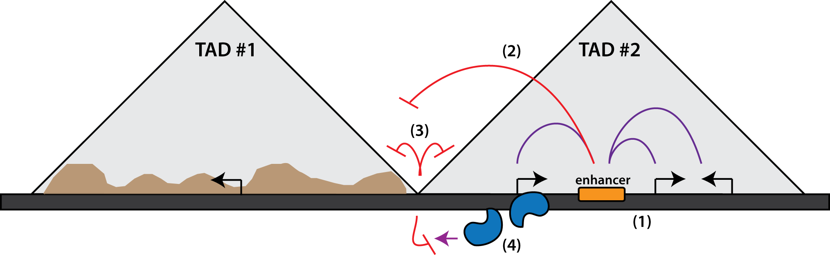

***Fig 2. Proposed functions of TADs in the genome.*** *TADs serve as regulatory units by providing insulated neighbourhoods for enhancers to activate their target genes (1), blocking the enhancers from activating the off-target genes (2), regulating the spread of chromatin marks in cis (3) and blocking the antisense transcription from encroaching into nearby genes (4). Figure inspired from the review by Dixon et al. (2016)* [*27*](https://paperpile.com/c/7HQKXY/YDcIe)

Due to high-paced technology development, last few years have seen a fascinating advance in our understanding of mechanism of loop and TAD formation. The first study performed using in-situ HiC visualized loops as regions of enriched contacts between long distance loci, and identified the insulator element CTCF, on loop anchors [26](https://paperpile.com/c/7HQKXY/CokeH). The loop anchors associated with cohesin subunits RAD21 and SMC3, along with CTCF motifs oriented in convergent direction corroborating previous evidences on the role of CTCF and cohesin in mediating DNA looping [31](https://paperpile.com/c/7HQKXY/XAkfG). Several models of loop formation have been proposed [32](https://paperpile.com/c/7HQKXY/Bby5g). However, the “extrusion-model” proposing loop formation via DNA loop-extruding smc complexes (cohesin and condensin) has received most evidence, and this model could also explain the 3D genome structure observed with the HiC data [33–35](https://paperpile.com/c/7HQKXY/mc3v5+YHgjj+FaWNu). Also, the in-silico models produced by the Mirny lab have proposed loop extrusion as a common mechanism behind formation of loops, TADs and chromosomal compartments [36–38](https://paperpile.com/c/7HQKXY/dcnf2+lTXYt+7nd7W). Despite all the in-silico evidence, the in-vivo evidence liking extrusion to loop formation was lacking, until the studies perturbing loop-associated factors emerged. A depletion of CTCF eliminated CTCF associated loops in the genome [39](https://paperpile.com/c/7HQKXY/ShlAF), while the depletion of cohesin eliminated all loop domains [40](https://paperpile.com/c/7HQKXY/oqIL4). A CRISPR mediated knockout (KO) of the cohesin release factor WAPL showed that the duration of association of cohesin complex (SCC2/SCC4) determines the length of loops [41](https://paperpile.com/c/7HQKXY/WMyxa). These studies reinforced a common mechanism behind loop and TAD formation. However, interestingly they also showed that compartments as well as histone marks remain unaffected upon loop depletion, suggesting an independent mechanism behind segregation of compartments. Another interesting point about studies linking cohesin and loop extrusion is that they don’t explain how cohesion physically extrudes chromatin, since no in-vivo extrusion activity of cohesin complex has been visualized [42](https://paperpile.com/c/7HQKXY/D3uUs). Another smc associated protein, condensin, however, has been shown to have the motor activity [43](https://paperpile.com/c/7HQKXY/tapyh) and recently, it’s in-vivo loop extrusion activity has also been visualized [44](https://paperpile.com/c/7HQKXY/mVXNz).

Single molecule imaging suggests that although cohesin can undergo rapid diffusion along DNA, its mobility is highly restricted by nucleosomes, and the DNA motor proteins can readily push cohesin along DNA [45](https://paperpile.com/c/7HQKXY/Wmjx4). On the same line, transcription has been proposed as a mechanism behind cohesin mediated loop extrusion [42](https://paperpile.com/c/7HQKXY/D3uUs). HiC studies showed that housekeeping genes are enriched at TAD boundaries [25,46](https://paperpile.com/c/7HQKXY/5Lm8o+qPVL9) providing further evidence linking transcription and TADs. A study last year showed that TADs could emerge in absence of transcription in flies, challenging the speculation of a causal link between transcription and TAD formation [47](https://paperpile.com/c/7HQKXY/GYHR), however another recent study showed that transcription could affect 3D genome structure by displacing cohesin from CTCF sites [48](https://paperpile.com/c/7HQKXY/SqUjd). Therefore, more research to investigate the association between transcription and 3D genome would be required.

### Mammalian X-inactivation : an interplay between multiple levels of epigenetic regulation

The process of mammalian X-inactivation (XCI) serves as an excellent example of how multiple levels of epigenetic regulations act in synchrony and influence each other. mammals (as well as *Drosophila*) have XX-XY form of sex determination, leading to an imbalance of X-chromosome gene dosage between sexes. This imbalance is corrected by an epigenetic phenomenon (dosage compensation) where one of the female X-chromosome is randomly inactivated during differentiation [49](https://paperpile.com/c/7HQKXY/D7RQk). In mouse, XCI happens in two waves, an imprinted paternal XCI is established at 4-8 cell stage, and the paternal X remains inactive in trophectoderm but is reactivated in the inner cell mass of the blastocyst (ICM) [50](https://paperpile.com/c/7HQKXY/bXnck). This is followed by the random XCI, which coincides with the down regulation of pluripotency factors such as Nanog, Oct4/Pou5f1 and Sox2 [51](https://paperpile.com/c/7HQKXY/BqVAL). The embryonic stem cells (ESCs) derived from the ICM, serve as a good model to study XCI, since XCI can be achieved simply by inducing ESC differentiation [52](https://paperpile.com/c/7HQKXY/fKUSW).

The X-inactivation center (Xic) is a locus on X-chromosome which is required to trigger XCI [53](https://paperpile.com/c/7HQKXY/F1Cso). Xic contains the non-coding RNA Xist, which coats the inactivating X-chromosome during XCI. Xist is negatively regulated by it’s antisense RNA Tsix, or positively regulated through a ubiquitin ligase Rnf12, in a dosage sensitive manner [54](https://paperpile.com/c/7HQKXY/TfuOH), both of which are controlled by the pluripotency factors [55,56](https://paperpile.com/c/7HQKXY/RsePt+XPGjC). On Xic, multiple putative regulators of Xist, such as Rnf12, Jpx, Ftx and Xpr have been shown to be important for specific targeting of X chromosome for the inactivation process (referred as “sensing”) [57](https://paperpile.com/c/7HQKXY/qmbTG). The mechanism behind selection of one of the two X-chromosomes for inactivation (referred as “choice”) remains elusive, although in mouse, Tsix has been suggested to be important for the process. One proposed mechanism of Tsix action could be that transient pairing of X-chromosome during ESC differentiation [58](https://paperpile.com/c/7HQKXY/vPJgU) somehow leads to an asymmetry in Tsix expression, followed by recruitment of repressive chromatin marks [59](https://paperpile.com/c/7HQKXY/QVTdV), which in turn leads to asymmetry in Xist expression.

During XCI, the Xist RNA coats the X-chromosome, which results in depletion of RNAP-II and the activating histone marks, such as H4 acetylation [60](https://paperpile.com/c/7HQKXY/u3KSf). The Xist coated chromatin then gets enriched in repressive chromatin marks such as H2AK119ub, H3K9me and H3K27me3 [61,62](https://paperpile.com/c/7HQKXY/PvhvU+jh1Br). It’s been proposed that Xist silencing followed by H2AK119ub could in turn recruit PRC1, which could indirectly recruit PRC2 through Jarid2, bringing in H3K27me3 [63](https://paperpile.com/c/7HQKXY/3bfqN). This rapid change of chromatin state is accompanied by a change in 3D conformation. The X-linked genes initially reside in nuclear periphery, outside the repressive nuclear compartment, and get recruited into it during inactivation [64](https://paperpile.com/c/7HQKXY/REm4n). Ultimately, the inactive-X is condensed to a heterochromatic form, known as the barr body [65](https://paperpile.com/c/7HQKXY/LNIOr). The mechanism of Xist spread has been investigated using RNA immunoprecipitation (RAP and CHART-seq) techniques, which suggested that Xist could exploit the chromosome conformation to spread to regions in spatial vicinity [66,67](https://paperpile.com/c/7HQKXY/k5z8j+Dzf36). Due to this intricate interplay of chromatin, non-coding RNA and chromosome conformation, that recent studies studying XCI have turned to multi-assay epigenomic techniques [68,69](https://paperpile.com/c/7HQKXY/HP27i+MeCuS). It’s evident that similar integrative studies would be required in future to study XCI and other such multi-stage phenomena.

## Regulation of transcription by the MSL complex

### Dosage compensation in flies via the MSL complex

In *Drosophila*, dosage compensation is achieved by the upregulation of a single X-chromosome in males [70](https://paperpile.com/c/7HQKXY/eWxtZ). Males absent on first (MOF), an enzyme that specifically deposits acetylation marks on Histone H4 Lysine 16 (H4K16ac) is required for the process [71](https://paperpile.com/c/7HQKXY/TzC0p). MOF associates with the male-specific lethal (MSL) complex, containing proteins MSL1, MSL2, MSL3, MLE (maleless) RNA helicase, and non-coding RNAs roX1 and roX2. roX1 and roX2 are lncRNAs containing stem-loop structures which which are expressed from the X-chromosome and seem to play a redundant role in dosage compensation [72](https://paperpile.com/c/7HQKXY/GA1F1). The E3 ubiquitin ligase MSL2 is only expressed in males and, in association with roX RNAs, provides specificity of the complex towards X-chromosome [73,74](https://paperpile.com/c/7HQKXY/UTFQg+IyTEP). Binding specificity to certain DNA motifs by the MSL2 CXC domain has been shown to bring X-specificity [75](https://paperpile.com/c/7HQKXY/bm3cr). MSL1 serves as a scaffold for binding to other proteins in the complex, and plays essential role in the assembly of the complex via its homodimerization and DNA binding property [76](https://paperpile.com/c/7HQKXY/roVdr). MSL3 enhances the acetylation activity of MOF [77](https://paperpile.com/c/7HQKXY/tLmAV) and contains a chromodomain which facilitates the spread of the complex towards gene ends [78](https://paperpile.com/c/7HQKXY/lHvCp). Finally, the MLE helicase stabilizes the roX RNAs and is important for it’s incorporation into the complex [79](https://paperpile.com/c/7HQKXY/faj6B).

Studies have shown that following this multi-stage assembly process, the complex is first recruited to certain specific loci in the genome referred to as high-affinity sites (HAS), followed by further spread to nearby loci [80](https://paperpile.com/c/7HQKXY/EK5s3). Sites of roX RNA expression serve as strong high-affinity sites. Further, the complex decorates the X-chromosome and deposits H4K16ac on promoters, gene bodies, as well as intergenic regions. The increase in H4K16ac has been shown to enhance transcription [81](https://paperpile.com/c/7HQKXY/85FQZ). Multiple studies have investigated the precise mechanism of this transcriptional enhancement using genome-wide techniques such as ChIP-seq [82](https://paperpile.com/c/7HQKXY/0UgUN), GRO-seq [83](https://paperpile.com/c/7HQKXY/YJVV4) and nascent RNA-seq [84](https://paperpile.com/c/7HQKXY/vPQfC). These evidences point out that transcriptional upregulation is a joint result of increased RNAP-II recruitment as well as processivity.

There are interesting parallels between *Drosophila* and mammalian dosage compensation systems. Both systems rely on an lncRNA expressed from the X-chromosome, which seem to be important for the recognition of the chromosome (**sensing**), and both of them rely on a global deposition of histone marks which associates with suppression or hyperactivation of genes. In *Drosophila* however, the problem of **choice** seems to be simplified, since the compensation occurs on the single male X-chromosome and the male-specific expression of MSL2 assures the sex-specificity. Nevertheless, this similarity suggests that questions in one species could be tackled by learning from another. For example, in parallel with the role of chromosome conformation in guiding the spread of Xist RNA, research performed in our lab and by others have shown that the spread of the MSL complex on the X-chromosome is guided by the 3D spatial proximity of HAS [85,86](https://paperpile.com/c/7HQKXY/NSQiJ+P4EQM). These observations also lead to further interesting questions. For example, studies have shown that despite a global inactivation of X-chromosome, about 15% of genes in humans and a 3% in mice, escape inactivation (referred to as escapees) [87](https://paperpile.com/c/7HQKXY/0oeKB). Escapee biology has been heavily studied in mammals, however studies to investigate whether different genes might also respond differently to dosage compensation has been lacking in flies.

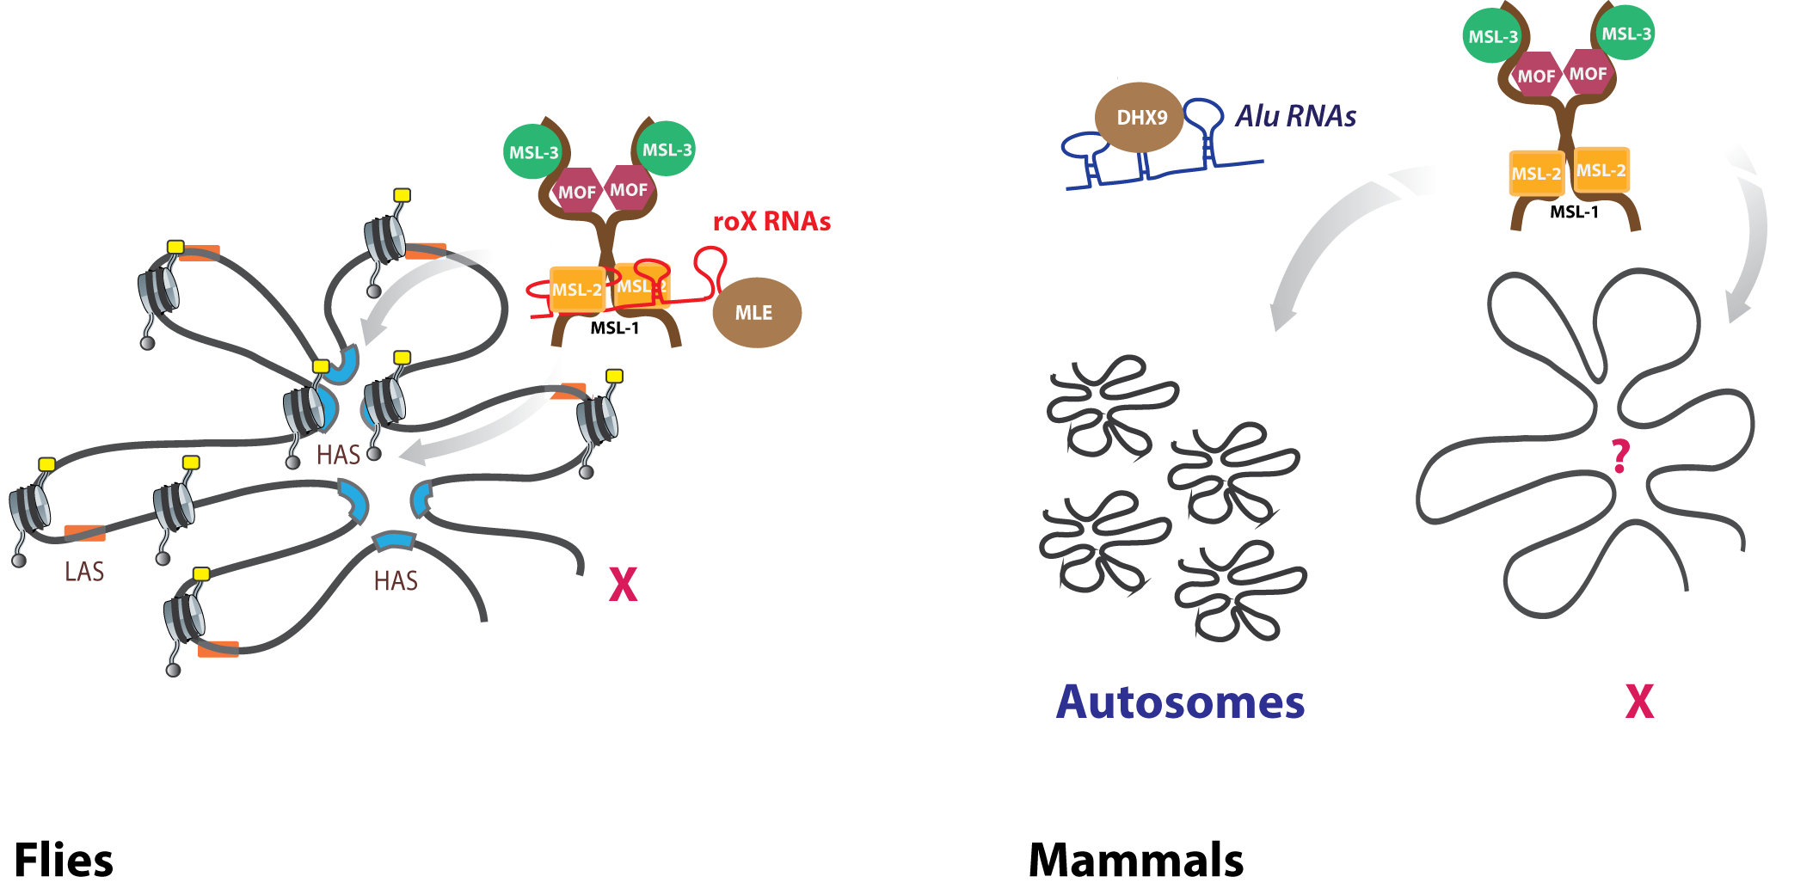

***Fig 3. Functions of the MSL complex in flies and mammals.*** *In* ***flies*** *the MSL complex assembles in presence of the roX RNAs, whose secondary structures are recognized and resolved by the maleless helicase (MLE), the complex then targets the high-affinity sites (HAS, blue) containing roX. The HAS cluster in 3D space, allowing efficient targeting by MSLs. The complex then spreads to low affinity sites (LAS, orange), depositing H4K16ac marks (yellow) on the X. In* ***mammals****, roX RNA is absent and the complex is believed to assemble in absence of any RNAs, and targets both X and autosomal sites. Specificity towards X-chromosome, as well as the role of chromosome conformation is unknown so far. MLE homolog DHX9 associates with a separate class of RNAs and performs independent functions (presented in results). Figure inspired from* [*88*](https://paperpile.com/c/7HQKXY/2VfjG)

### Functions of MOF and MSL complex in mammals

Proteins of the MSL complex are conserved from flies to humans, and evidence suggests that MOF is responsible for majority of H4K16ac [89](https://paperpile.com/c/7HQKXY/msbVl). Human homologs of MSL1, MSL2, MSL3 and MOF have been co-purified, suggesting that the bulk of the MSL complex stays together. It’s compelling to speculate that role of MSL complex along with the role of H4K16ac might have diverged, considering that mammalian dosage compensation works via a different mechanism, and no ortholog of roX RNAs have been discovered on the X-chromosome so far [90](https://paperpile.com/c/7HQKXY/oFsHq). However, there is evidence that the active X-chromosome in mammals might also be upregulated [91,92](https://paperpile.com/c/7HQKXY/N3hW+7tR0) and a recent study has supported the role of MOF mediated H4K16ac in enhancing transcription on a subset of X-linked genes [93](https://paperpile.com/c/7HQKXY/92q6). Apart from its association with dosage compensation, MOF mediated H4K16ac have also been implicated in embryogenesis and oncogenesis [90,94](https://paperpile.com/c/7HQKXY/uS0UJ+oFsHq). However, this should be noted that MOF is also associated with another complex, called the non-specific lethal (NSL) complex, which is conserved from flies to humans, and is involved in depositing H4K16ac on housekeeping and constitutively expressed genes [95](https://paperpile.com/c/7HQKXY/vrlRe). Therefore some functional outcomes of H4K16ac could relate to the MOF-MSL complex, while others to the MOF-NSL complex [96,97](https://paperpile.com/c/7HQKXY/ajyuy+oqyLe).

In flies, the MOF-NSL complex is shown to be responsible for the bulk of H4K16ac on the gene promoters, while the MSL complex deposits the mark on gene bodies of the X-chromosome. A recent study from our lab showed that in mammals, however, MSL and NSL proteins colocalize on promoters of target genes on both X and autosomes [96](https://paperpile.com/c/7HQKXY/ajyuy). The study also showed that the MSL mediated H4K16ac contributes to the regulation of Tsix expression and the depletion of MSLs before ESC differentiation leads to chaotic XCI. However, the lack of specificity towards the X-chromosome and co-localization with NSL proteins at the promoters raises further questions about the specific genome-wide role of MSL complex, and its role on the mammalian X-chromosome.

Apart from the MSL complex, the human ortholog of MLE helicase, DHX9, is also conserved in mammals, and has been shown to unwind both DNA and double-stranded RNA [98–100](https://paperpile.com/c/7HQKXY/OMkOx+PckWG+1UVfa). However, in absence of it’s association with MSL complex, the function of it’s RNA helicase activity in mammals had not been studied in detail. A study presented in this thesis investigates the RNA binding partners of DHX9 in mouse and humans, and proposes a novel evolved function of DHX9 in suppression of undesired expression of RNAs [101](https://paperpile.com/c/7HQKXY/TfQb6).

## High-throughput techniques to study transcriptional regulation

Due to consistently reducing cost of sequencing, increase in our ability to multiplex many samples, and sequence genetic material from as low as a single cell, a large number of biologists now rely on genome-wide assays for their research. Researchers have quickly realized that the ability to store, process, analyze, interpret and visualize such datasets would become a major challenge for biology [102](https://paperpile.com/c/7HQKXY/VxKGq). Below I would focus on recent developments in techniques employed in study of protein-DNA interactions, chromosome conformation and transcription.

### ChIP-Seq : current standards and challenges

Chromatin Immunoprecipitation followed by sequencing (ChIP-seq) is the broadly used method to detect genome-wide protein-DNA interactions in cells [103](https://paperpile.com/c/7HQKXY/guq8V). ChIP-seq allows us to probe genome-wide binding sites for TFs, or study the distribution of histone marks. It has led to numerous discoveries and has been used by large consortia such as ENCODE, to map cell-type specific regulatory elements such as enhancers in the human genome [17](https://paperpile.com/c/7HQKXY/mU5yX). ChIP-seq experiment involves DNA protein cross-linking (using UV or formaldehyde), chromatin fragmentation (using sonication or enzymes), purification of protein-DNA crosslinks with or without antibody (called “ChIP” and “Input” DNA), and high-throughput sequencing of associated DNA. Since the technique involves cross-linking, shearing, and affinity based pull-down, the data obtained from the protocol is directly affected by three major factors : 1) **cross-linking efficiency** of proteins might be affected by its nature of DNA binding (direct vs indirect, transient vs stable) 2) **Stability** of the protein epitope under shearing and washing conditions would affect enrichment and 3) **Antibody cross-reactivity** would result in detection of non-specific interactions [104,105](https://paperpile.com/c/7HQKXY/bHbsa+WUSG5). Variations of ChIP-seq protocols as have been developed to tackle biases, such as MNase-ChIP [106](https://paperpile.com/c/7HQKXY/4zoRN), to account for shearing and stability bias, and DamID-seq [107](https://paperpile.com/c/7HQKXY/YeTti) to account for antibody bias. Further variants such as iChIP [108](https://paperpile.com/c/7HQKXY/JFHuK), Mint-ChIP [109](https://paperpile.com/c/7HQKXY/sHPvn) and RELACS [110](https://paperpile.com/c/7HQKXY/F5Op) aim to increase the multiplexing ability and allow reducing the number of cells. Such methods might receive more popularity in future.

The analysis of ChIP-seq data involves mapping of sequenced DNA to a reference genome, and detection of regions enriched in ChIP DNA (called as “Peaks”) using Input DNA as a negative control. Peaks represent the “detected” binding sites of the TF or histone mark of interest. These peaks are then used to find DNA binding motifs for TFs, detect target genes of interest, and integrate these results with other assays (such as RNA-seq) to understand gene regulation [111](https://paperpile.com/c/7HQKXY/N1Qyf). Apart from the sources of bias described above, the sequencing depth or genomic nucleotide content (GC bias) could lead to sample-specific bias in ChIP-seq, and various “normalization” methods have been developed to account for such biases [112–115](https://paperpile.com/c/7HQKXY/BLYx+20xE+sqSW+4B2b). Our group previously developed “deepTools” [116](https://paperpile.com/c/7HQKXY/dAmb9), a set of tools that allow users to identify biases and perform such normalizations, and visualize the downstream results in a user-friendly manner. However, due to improvements in experimental and analysis methods, new challenges have emerged as previous issues have been resolved. Specifically, increase in multiplexing ability has simplified performing routine large-scale experiments [110](https://paperpile.com/c/7HQKXY/F5Op), and the demand for user-friendly tools for differential ChIP-Seq analysis between conditions [117](https://paperpile.com/c/7HQKXY/GWMex), quantitative normalization using external controls [118,119](https://paperpile.com/c/7HQKXY/L0a8Y+Q1F5W), and large-scale processing and integration of datasets has been increasing. The development of tools that allow multi-sample comparison and integration of quality control and analysis would be widely appreciated. This was the motivation behind our recent update of deepTools [120](https://paperpile.com/c/7HQKXY/KT1A).

### Analysis of chromosome conformation

Past 10 years have seen lots of development in genome-wide techniques to capture physical interactions between chromatin loci inside the cell. The first popular measure to detect chromatin interactions between loci was called **3C** (chromosome conformation capture). 3C involved cross-linking the chromatin such that the regions in spatial proximity inside the nucleus get linked to each other followed by the digestion of chromatin using restriction enzymes (REs) and the ligation of close-by DNA fragments. These ligated fragments could then be amplified using PCR primers specific to the region of interest, followed by qPCR to measure interaction frequency [121](https://paperpile.com/c/7HQKXY/fI6dV). 3C was extended to 4C, where all regions interacting with a locus of interest (referred to as “bait”) could be detected by inverse PCR using outward facing primers on the 3C-ligated product, followed by hybridization to a microarray chip to detect interaction [122](https://paperpile.com/c/7HQKXY/Tdvoq). The 5C technique introduced later used highly multiplexed ligation-mediated amplification (LMA) to first “copy” and then amplify parts of the 3C library followed by detection via microarrays or sequencing [123](https://paperpile.com/c/7HQKXY/iQjwU). Finally the genome-wide version of 3C, called HiC, involved biotin-based pull down of 3C fragments, followed by library preparation and paired-end sequencing of the enriched fragments [24](https://paperpile.com/c/7HQKXY/lrwqn). An improved version of HiC protocol performs restriction digestion and ligation of 3C fragments inside intact nuclei, avoiding non-specific interactions. This technique, referred as in-situ HiC [26](https://paperpile.com/c/7HQKXY/CokeH) is currently the most popular method for genome-wide detection of chromatin contacts.

All the 3C-based methods however, suffer from two issues : 1) The cross-linking of chromatin makes the technique less quantitative and the proximity ligation introduces additional biases; 2) These methods only allow detection of pair-wise contacts between two genomic bins. Due to its limitations and biases, together with the observed discrepancy between 3C and microscopy-based visualization of interactions, the interpretation of 3C-based proximity as molecular proximity has been criticised [124–126](https://paperpile.com/c/7HQKXY/hP49c+uPOkQ+bw4gm). Recent innovations in chromosome conformation techniques, such as GAM [127](https://paperpile.com/c/7HQKXY/1HBZe), SPRITE [128](https://paperpile.com/c/7HQKXY/RVeGc) and damC [129](https://paperpile.com/c/7HQKXY/cGWVb) and have tried to overcome these limitations. SPRITE is particularly interesting since it detects multi-loci chromatin interactions via a relatively simple split-pool barcode tagging of the cross-linked chromatin fragments, and can also detect DNA-RNA interactions [128](https://paperpile.com/c/7HQKXY/RVeGc). It’s not unlikely that one of these new innovations might replace in-situ HiC as a primary method for analysis of 3D genome.

HiC libraries are sequenced as paired-end, where ideally, one read in a pair comes from one of the interacting loci in the genome while the second read comes from another [24](https://paperpile.com/c/7HQKXY/lrwqn). However, due to the issues with ligation efficiency, biotinylation and IP of the interacting pairs, many “invalid” HiC pairs also get sequenced. Analysis of HiC data begins with separate **mapping** of the two reads in a pair, followed by pairing and **filtering** of reads. To consider a pair “valid” two reads should come from different fragments which were ligated during the protocol, and therefore should have a restriction site in between them. After filtering of valid pairs, the genome is divided into bins, and the number of paired-end contacts between all bins are calculated to create a HiC matrix.

Initial HiC protocol used whole cell lysis along with REs such as **Hind-III**,with low cutting frequency, leading to low-resolution HiC matrices. In contrast, the use of REs with high cutting frequencies such as **Dpn-II** (4-cutters) combined with other improvements, the recent in-situ HiC protocols has allowed us to create higher resolution matrices. In either case, the highest resolution matrices could be obtained by using restriction enzyme cut-sites as “bins” in the genome [85,130](https://paperpile.com/c/7HQKXY/TD0pI+NSQiJ).

Several known and unknown factors in the HiC protocol could affect interpretation of the observed data. Normalization methods have been developed to explicitly account for some biases, such as the effective length bias (due to the size of the restriction fragment), GC content bias, and the mappability bias [131,132](https://paperpile.com/c/7HQKXY/iaoKj+x4cfu). However since not all source of biases are known in the experiments, the matrix balancing methods, which try to account for both known and unknown biases, have been most popular [133](https://paperpile.com/c/7HQKXY/zhIVa). Matrix balancing methods, such as ICE (Iterative Correction and Eigenvector decomposition) [134](https://paperpile.com/c/7HQKXY/RjifE), and Knight and Ruiz method [26,135](https://paperpile.com/c/7HQKXY/CokeH+o1Ccu), assume uniform visibility of all genomic loci and therefore ensure equal sum of row and column values. Both methods have been shown to be useful in the analysis of HiC data.

HiC interaction matrices reveal that loci which are closer on the linear genome also tend to interact more frequently. In normal interphase cells, a distance dependent decay of interactions is observed, which follows a power law. This interaction is disrupted in mitotic chromosomes, which represent a reduction of short-range and an increase in long-range interactions [136](https://paperpile.com/c/7HQKXY/phqy2). It also served as a quality control signal for the comparison of normal samples. However, the interaction frequency could also get exaggerated due to nonspecific proximity ligation effects, and therefore for some analysis, such as detection of chromosomal compartments, a correction of proximity ligation effect is needed in addition to ICE correction.

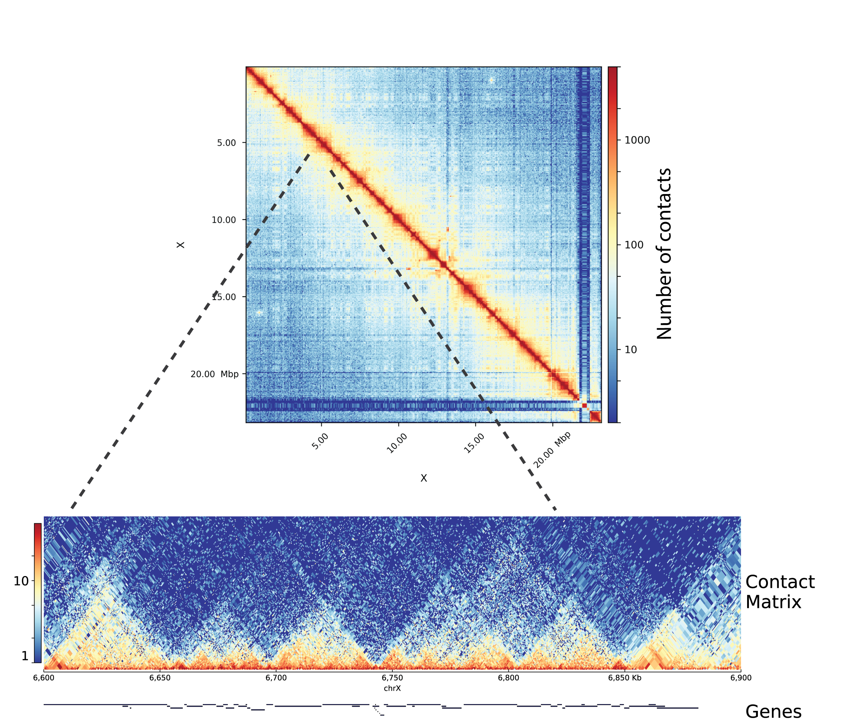

***Fig 4. Visualization of a normalized HiC contact matrix.*** *The HiC matrix* ***(top)*** *represents all-to-all contacts between bins in the genome, and is therefore symmetric. After cutting the matrix from diagonal and rotating it* ***(bottom)****, domains (TADs) in shape of triangles become visible.*

Normalized HiC matrices could be used for detection of TADs, loops, compartments, modeling of 3D genome and visualization of genomic interactions. Numerous software solutions have been developed over the last few years for the processing and analysis of HiC data that allow these applications (Table-2). Detection of loops and compartments have been formalized better than TADs due to their distinct properties. The original method for detection of chromosomal compartments [24](https://paperpile.com/c/7HQKXY/lrwqn) assumes that regions with shared neighbourhood have correlated interaction profiles. It therefore transforms the HiC matrix into a correlation matrix, followed by partitioning of chromosomes into regions of correlated interactions using principal component analysis (PCA). This method has now been implemented in multiple tools (Table-2). The method used for genome-wide detection of loops utilizes high-resolution in-situ HiC data and searches for clusters of matrix entries with enriched interactions relative to a local background. This method referred to as HiCCUPs [26](https://paperpile.com/c/7HQKXY/CokeH), has been implemented in the Juicer pipeline [137](https://paperpile.com/c/7HQKXY/sm4pj).

Methods for detection of TADs have been evolving fast over the last few years. The first group describing TADs [25](https://paperpile.com/c/7HQKXY/5Lm8o), observed that within a TAD the bins closer to the boundary have a high interaction bias towards bins in the middle. They developed a metric that quantified the contacts of a bin with a larger region upstream (A) and downstream (B) of that bin and compared it to the contact probability expected under a null distribution of (A+B)/2 . This directionality index (DI) was used as an observation to infer the true directionality bias via a hidden markov model (HMM), which predicted the topological domains. Later, methods based on maximum likelihood segmentation [138](https://paperpile.com/c/7HQKXY/zYmCW), breakpoint detection [139](https://paperpile.com/c/7HQKXY/eEmVz), and hierarchical clustering [140](https://paperpile.com/c/7HQKXY/aj7GY) were developed. In principle, all these methods formalize the observation that TADs are visualized as domains of enriched contacts relative to their neighbourhood on a HiC matrix, and try to produce the most similar set of predictions corresponding to this visual observation. Multiple studies showed that genome organization is hierarchical, and TADs have been speculated to be the level of this hierarchy which are not structurally, but rather functionally privileged [140,141](https://paperpile.com/c/7HQKXY/aj7GY+5EIMN) . Therefore ideal methodology for TAD detection has still not been settled, and the benchmarking of TAD calling methods rely on visual identification of true positives [142](https://paperpile.com/c/7HQKXY/YNO3G).

### Transcript profiling methods and analysis

Transcriptomics (study of all transcripts in the cell), has been one of the most popular fields where NGS is being applied. The most widely used bulk RNA-seq methods (studying a population of cells) are poly-A or ribo-depleted RNA-seq. In **poly-A** RNA-seq, oligos are used to enrich for mRNA (containing poly-A tails) while in **ribo-depleted** RNA-seq, all RNAs (except ribosomal RNA) are sequenced [143](https://paperpile.com/c/7HQKXY/8QPmH). Ribo-depleted RNA-seq allows for analysis of poly-A along with non poly-A RNA, such as unprocessed transcripts and RNAP-III transcribed RNAs. However, detection of all kinds of RNA requires a high depth of sequencing, the capacity of sequencing library to capture transcripts various lengths, and enough input material from the cells to avoid RNA composition effect (masking of lowly expressed transcripts by abundant RNA). Methods have been developed to enrich for specific RNA species in the cell, such as small (<50 nt) RNAs [144](https://paperpile.com/c/7HQKXY/sZkFN), transiently transcribed RNAs [145](https://paperpile.com/c/7HQKXY/uafS9) , and circular RNAs [146](https://paperpile.com/c/7HQKXY/zV9Fp).

The analysis of RNA-seq data [147](https://paperpile.com/c/7HQKXY/H8rS4) includes **trimming** adaptors and low quality bases from single or paired-end reads, followed by **mapping** of the reads to a reference genome. Genomic mapping of RNA-seq requires splice-aware alignments (allowing for splitting of reads mapping to splice junctions, in order to map across introns). In order to obtain the estimate of transcript numbers in the cells, counting and **summarizing** of reads is performed afterwards, using gene annotations as reference. Usually, RNA-seq is performed on multiple biological **replicates** of two or more groups (control vs knockdown, tissue 1 vs tissue 2 etc.), in order to find genes or transcripts that vary significantly between the groups (called **differential expression** analysis). Differentially expressed genes are used to look for functional enrichments of gene categories using methods like Gene Ontology (GO) analysis [148](https://paperpile.com/c/7HQKXY/nFMOb). Gene level differential expression analysis has been standardised in the field, while methods for quantification and differential expression of transcript isoforms are still under active research [149](https://paperpile.com/c/7HQKXY/WyJqp). A special case of differential expression is where a large number of transcripts are affected, such as knockdown of TFs regulating housekeeping genes, or genome-wide transcriptional activation/repression [150](https://paperpile.com/c/7HQKXY/qYhvb). These cases require normalization using external, non-changing controls referred to as **spike-ins** [151](https://paperpile.com/c/7HQKXY/vBxsl). For special applications of RNA-seq such as detection of **circular RNAs**, the mapping and summarization of reads requires an entirely different strategy, and various tools have been developed to facilitate this [152](https://paperpile.com/c/7HQKXY/2MwPq). Another special application of RNAseq is for the identification of **RNA editing** [153](https://paperpile.com/c/7HQKXY/b5SA3), which require stringent mapping and variant detection followed by multiple rounds of filtering. Due to evolving standards, these applications still rely on custom analysis.

Although RNA-seq has helped with genome-wide annotation of transcripts in the genome, it requires fragmentation of RNA, making it difficult to accurately detect transcription start sites (TSSs) and perform promoter profiling. Techniques for promoter profiling, such as Cap Analysis of Gene Expression (**CAGE**) exploit the fact that RNAP-II adds a methyl-Guanosine cap to the 5’-end of the transcript, and perform the biotinylation and RNAse digestion to purify full length cDNA [154](https://paperpile.com/c/7HQKXY/khvpL). The cDNA is fragmented to later purify a short tag around the 5’ start site, followed by sequencing. The sequenced tags, which are short (<50bp) and single-ended for most protocols, are then mapped to reference genome and the promoters are identified using clusters of tags. Even though promoter-profiling protocols capture the expression from the RNAs similar to RNA-seq, the correlation between gene expression estimates obtained from RNA-seq and promoter-profiling methods has historically been low [155](https://paperpile.com/c/7HQKXY/66KIl). Also, unlike RNA-seq there has been absence of biological replicates from most CAGE experiments, and current CAGE analysis tools do not provide the ability to use replicates for differential expression analysis, limiting the use of this assay in promoter profiling.

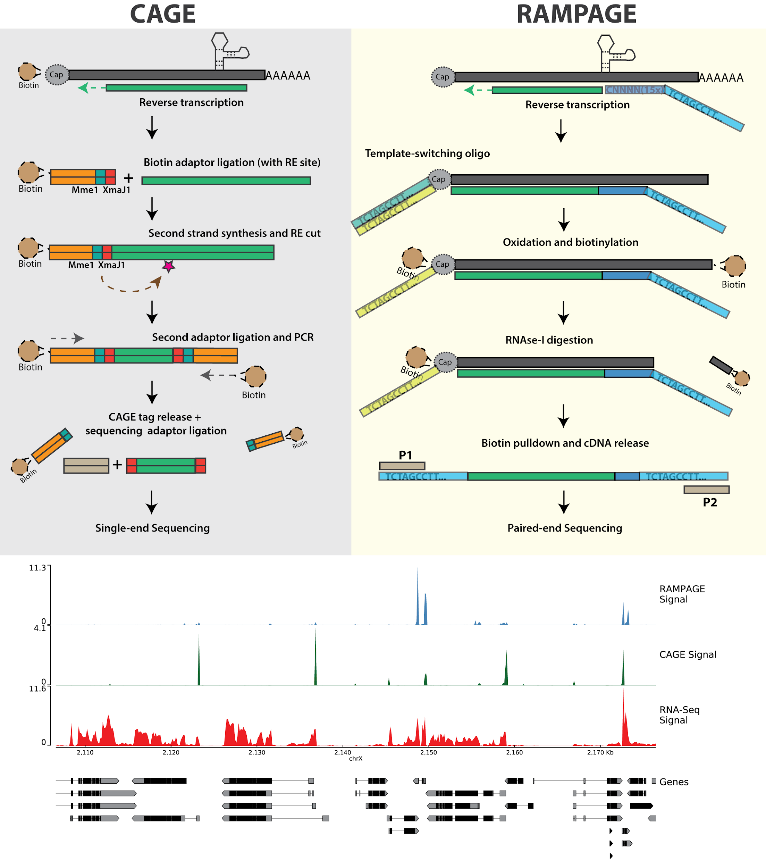

***Fig 5. Overview of popular promoter-profiling methods and the resulting data.******CAGE*** *begins with biotinylation and pull-down of RNA, followed by reverse transcription and fragmentation of cDNA using restriction enzymes (REs) to produce short (21 bp) tags.* ***RAMPAGE*** *on the other hand, uses template-switching oligos containing sample barcodes and PCR primers before biotinylation and pull-down, cutting several steps from the traditional design. Both protocols produce sharp signal at gene promoters (TSS), in contrast to to RNA-seq (red) which produces signal all over the gene body. Illustrations inspired by* [*156*](https://paperpile.com/c/7HQKXY/YpL6a) *and* [*157*](https://paperpile.com/c/7HQKXY/TnrB8)*.*

The earliest methods to identify promoters combined CAGE tags with overlapping 5’ start site into a group called **CTSS** (CAGE Tag Start Sites), and the CTSS overlapping with each other were grouped into **tag clusters** [158](https://paperpile.com/c/7HQKXY/1zubo). However, this approach (referred as “**distclu**”) used an arbitrary cutoff to avoid overlap between nearby tag clusters, which does not necessarily correspond to cluster shape. Another method (referred to as “**paraclu**”), identifies tag clusters as the segments of genome that maximise the density of CAGE tags per nucleotide within them [159](https://paperpile.com/c/7HQKXY/KAzkY). Clusters at various scales could be produced by varying the minimum density (***d***) parameter, where small values of *d* produce large, loose clusters, while large values of *d* produce small, dense clusters. The algorithm finds all clusters for all values of *d* , and therefore reports subclusters (peaks within peaks) of TSS. Despite the improvements, the method suffers from the issue that it does not correct for the sample-specific biases in the protocols. Issues such as RNA composition effect and capture efficiency of CAGE tags introduce background noise, and affect the detection of robust, reproducible tag clusters. Another method called **reclu** tries to filter detected clusters based on irreproducible discovery rate (IDR) method [160](https://paperpile.com/c/7HQKXY/3vP9D). Nevertheless, methods that allow detection of robust tag clusters by using information from biological replicates would further improve the analysis.

## Aims

The overall goal of my studies was to perform analysis and integration of epigenomics and transcriptomics data, specifically ChIP-seq, HiC, RNA-seq and CAGE, in order to understand the function of the male-specific lethal (MSL) complex in flies and mammals.

In order to achieve the above goal, several bioinformatic challenges discussed before needed to be addressed. The overall goal of the thesis could therefore be divided into three components:

1. Developing methods for high-resolution analysis of HiC data in order to understand the relationships between chromosome conformation and gene regulation in flies that can be applied to understand the mechanism of action of MSLs.
2. Improving existing methods of analysis of promoter profiling in order to perform high-resolution analysis of MSL-mediated dosage compensation on the X-chromosome in flies.
3. Finally, developing workflows for quality control, analysis and integration of data from multiple epigenomic assays, specifically in an allele-specific manner, and utilize them to understand the function of MSLs on the X-chromosome in mammals.

# 

# Results and Discussion

The following chapter summarizes the methods and insights from the six manuscripts presented in the appendix of this thesis.

Appendix A.1 corresponds to Ramirez and Bhardwaj et. al (2018) where we perform high-resolution analysis of online Hi-C datasets in flies and explore the relation of chromosome conformation with regulatory elements and transcription. We also introduce our tools and resources for HiC analysis.

Appendix A.2 corresponds to Wolf et. al (2018) which describes implementation of our HiC analysis tools into a Galaxy web-server for end-to-end HiC analysis.

Appendix A.3 corresponds to Bhardwaj and Semplicio et. al (2018) where we introduce a new experimental protocol and analysis software for promoter-profiling, and apply them for the analysis of dosage compensation in flies. Experimental data for this manuscript was generated by Giuseppe Semplicio.

Appendix A.4 corresponds to Aktas and Ilik et. al (2017) where we describe the function of mammalian ortholog of MLE (DHX9) in controlling genome-wide RNA processing defects mediated by Alu transposons in humans. Experimental data for this manuscript was generated by Tugce Aktas and Ibrahim Ilik.

Appendix A.5 corresponds to Ramirez and Ryan et. al (2016) which introduces an upgrade the previously published toolkit from our group “deepTools”, expanding it’s scope to various epigenomic and transcriptomic assays.

Appendix A.6 corresponds to Bhardwaj and Heyne et. al (2018) which introduces “snakePipes”, a set of scalable and flexible pipelines that simplify integrative analysis of epigenomic data.

## Insights from high-resolution chromosome conformation analysis in flies

Previous study from our lab investigated the conformation of the male X-chromosome in flies in order to understand the mechanism of targeting of the MSL complex [161](https://paperpile.com/c/7HQKXY/KKfN). Fidel Ramirez, Thomas Lingg and others generated HiC profiles in *Drosophila* S2 cells using the Hind-III RE, and produced HiC matrices at an average resolution of 4.5 Kb, using the Hind-III cut-sites in the genome as bins. Analysis of this data revealed that MSL2 bound high-affinity sites cluster together on 3D space on the X-chromosome, facilitating the spreading of the MSL complex. During the study read filtering, matrix generation and normalization using ICE method [134](https://paperpile.com/c/7HQKXY/RjifE) was implemented by Fidel in a command line tool called HiCExplorer.

Studies published later [162,163](https://paperpile.com/c/7HQKXY/WOaV+xe5l) performed HiC using the 4-cutter Dpn-II enzyme. This data, combined with the ability of HiCExplorer to create matrices at restriction fragment (RF) resolution, allowed us to study the Fly genome at sub-kilobase resolution (~570 bp) and further understand the relationship between DNA elements, chromosome conformation and transcription [164](https://paperpile.com/c/7HQKXY/OD5k).

### Setup of a HiC analysis workflow

In order to facilitate high-resolution analysis of HiC data, we first improved the TAD calling method described in [161](https://paperpile.com/c/7HQKXY/KKfN) (see details in [164](https://paperpile.com/c/7HQKXY/OD5k)). Specifically, 1) The original matrix is transformed into a z-score matrix before calculating the TAD-separation score 2) For each bin in the genome, the TAD-separation score is calculated for multiple window sizes around the bin and averaged to reduce noise 3) After identification of bins with “local minima” of TAD-separation scores, a Wilcoxon rank-sum test is performed to compare the distribution of that bin with the nearby (left and right) regions, followed by multiple testing correction.

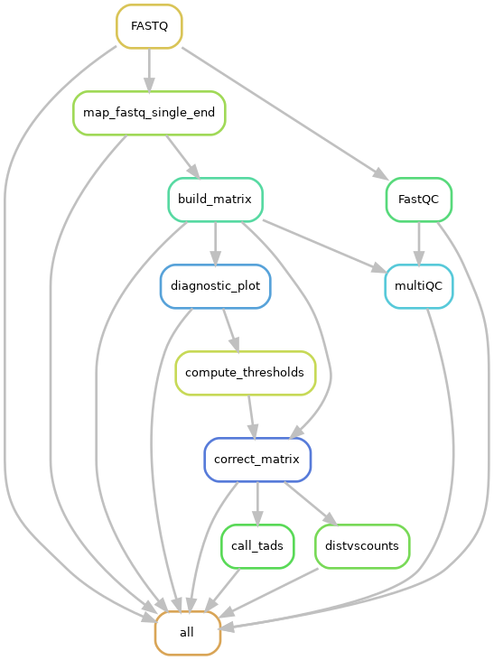

*Fig 1. A directed acyclic graph (DAG) of the HiC workflow. It includes FASTQ file quality controls (FastQC) mapping, matrix generation, QC plots, matrix correction and TAD detection. The step marked as “all” collects the final outputs. This workflow has been implemented in snakePipes (see last section).*

I utilized HiCExplorer to create an end-to-end HiC analysis workflow implementing various analysis steps (see Introduction). Computational workflows are like automated protocols that perform a series of analysis steps, ensuring that dependencies between steps are properly resolved (for example, re-running a 5-step workflow with a missing file at step-4 re-runs both step-4 and 5 to ensure that dependent files are updated). Workflows, combined with containerization (each step running in it’s own virtual environment) ensure the transferability and reproducibility of analysis results [165](https://paperpile.com/c/7HQKXY/kCTk). This HiC workflow could be utilized for reproducible analysis of both in-house and online HiC datasets (Fig 1). This workflow is now implemented in our epigenomic analysis toolkit called snakePipes, and is routinely used in-house for HiC data analysis.

### Relationships between TADs, regulatory elements, and transcription in flies

Using the newly implemented version of HiCExplorer tools, we detected ~2800 boundaries in wild-type female *Drosophila* Kc cells, and found that most (77%) of the TAD boundaries in flies associate with gene promoters. These promoter boundaries associate with active chromatin and have higher DNAse hypersensitivity signal (from DHS-seq data) and stronger TAD-separation score than non-promoter boundaries. A carefully performed DNA motif enrichment analysis discovered that promoter-boundaries are enriched with a specific set of core-promoter motifs : motif-1 (M1BP), 2 (Beaf32), 6, 7 (ZIPIC) and 8, while non-promoter boundaries are enriched for some classically known insulator motifs : CTCF, Ibf and Su(Hw). Interestingly, we find that the motifs combinations, rather than the number of motif instances seem to affect the strength of boundaries. Certain motifs combinations, such as Beaf32 + Pita make the boundaries stronger while others, such as Su(Hw) + ibf make them weaker. Our study also challenged the previous studies showing that the number of ChIP-seq peaks of the insulator proteins correlate with boundary strength, and rather emphasised the usefulness of considering motifs at boundaries.

To understand whether there exists a genetic code at boundaries, we used various classification methods, such as logistic regression, random forest and gradient boosting models to predict boundaries using DNA motifs. These methods performed similarly well in identifying boundaries, with a sensitivity and specificity of over 70% on an independent test data. Interestingly the classifiers showed that DNAse hypersensitivity is the most important feature in boundary prediction, suggesting that the accessibility of DNA motifs might be a crucial factor for boundary formation.

Using re-analysis of RNA-seq data from modENCODE, we investigated the relationship between our high-resolution TADs and transcription. We find that TADs serve as units of coordinated transcription during *Drosophila* development. Expression of genes with TADs are highly correlated throughout development while genes separated by TAD boundaries show a lack of correlation. We also find that genes at TAD boundaries have expression features of housekeeping genes (high, constitutive expression with low variability) which confirmed previous studies linking housekeeping genes to TAD boundaries.

The catalogue of high-resolution boundaries generated in this study functions as useful resource in understanding the biology of MSLs, as well as other protein complexes in context of 3D chromatin. For example, chromator, a member of MOF-associated NSL (non-specific lethal) complex was found to be associated with various motifs at boundaries (Fig. S3I of [164](https://paperpile.com/c/7HQKXY/OD5k)). Further the data produced and analysed during our study allowed us to re-evaluate our previous finding whether the high-affinity sites cluster in 3D space. Using clustering of contact aggregates from the data, we observed that the HAS-HAS clusters emerge after zygotic genome activation (at nuclear cycle 14, together with the establishment of TADs) when MSL2 expression begins [166](https://paperpile.com/c/7HQKXY/LgjB). Similar to [161](https://paperpile.com/c/7HQKXY/KKfN), HAS-HAS clusters were observed in both male and female cells, suggesting that the MSL complex could utilize the pre-existing 3D conformation of the X-chromosome for spreading.

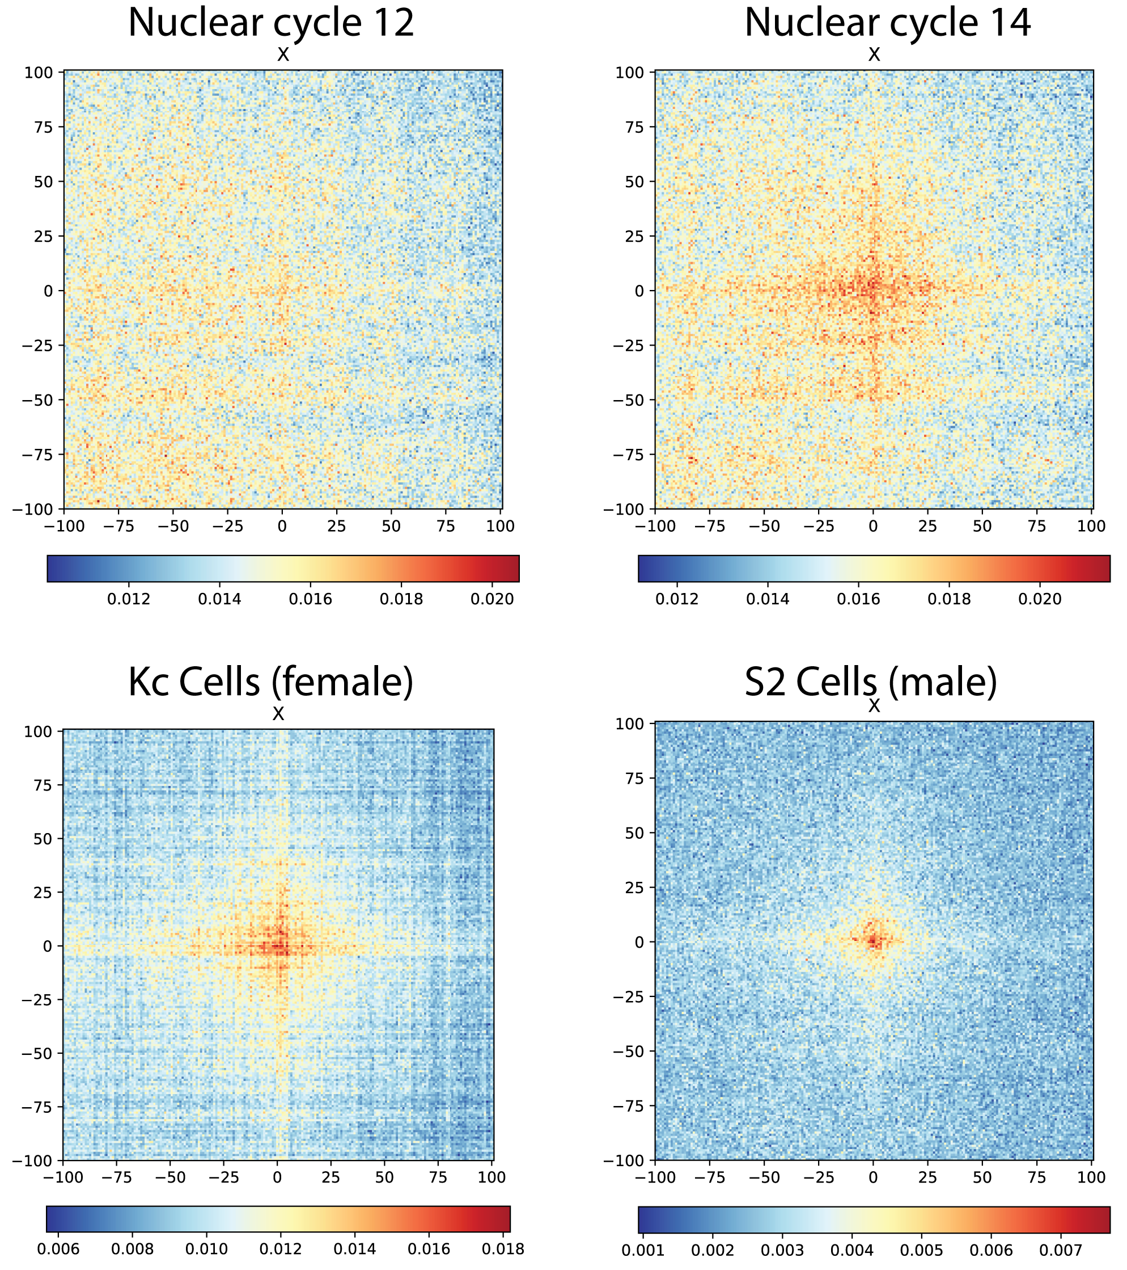

***Fig 2. The HAS interaction network on X-chromosome.*** *An aggregate contact matrix containing mean interactions over all possible contacts within a genomic distance of 0.5 Mb to 15 Mb of HAS loci. Submatrices were extracted for each HAS from the corrected HiC matrix, and the counts were further normalized to total counts of each submatrix. The data from multiple recent in-situ HiC studies* [*47,162–164*](https://paperpile.com/c/7HQKXY/GYHR+WOaV+xe5l+OD5k)*, analyzed during our study.*

### Resources for HiC analysis and visualization

During our analysis of chromosome conformation in flies, we improved on the methods developed and presented in the last study from our lab [161](https://paperpile.com/c/7HQKXY/KKfN). Fidel and I added further functionality to HiCExplorer, such as improved TAD calling, a method to import and export multiple file formats, and plotting methods. In collaboration with Jose Villaveces (MPI-Biochem), we developed the visualization tool HiCBrowser, which can be used as a standalone tool to browse HiC and other genomic data (ChIP-Seq, RNA-seq etc.). In order to allow biologists to investigate their own gene or region of interest in context of TADs, we developed a web server that contains online HiC data pre-processed using our HiC workflow, along with other genomic data ([http:://chorogenome.ie-freiburg.mpg.de](http://chorogenome.ie-freiburg.mpg.de/)). Further in collaboration with Joachim Wolff and Bjoern Gruening, we implemented HiCExplorer along with other tools in galaxy, that facilitates GUI based end-to-end analysis of HiC data for biologists [167](https://paperpile.com/c/7HQKXY/O9HWm). We hope that these resources would facilitate easy and user-friendly HiC analysis for biologists.

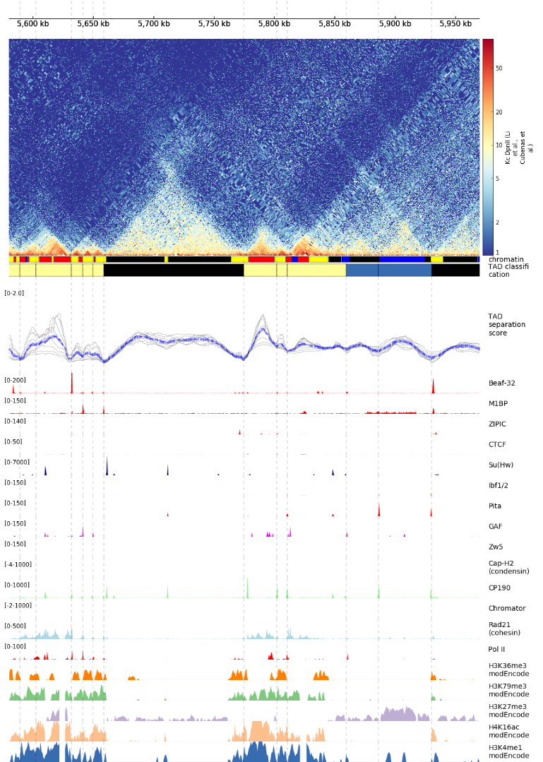

***Fig 3: Chorogenome navigator.*** *Snapshot of a ~350kb region around MOF in Drosophila Kc cells, from the chorogenome navigator web server.*

## Using promoter-profiling to study MSL-mediated dosage compensation in flies

### Development of the MAPCap protocol

In flies, we wanted to understand how MSL mediated dosage compensation works at the level of individual transcription start sites (TSSs), through promoter-profiling. In collaboration with Giuseppe Semplicio, I contributed to the development of a new experimental protocol for promoter-profiling, termed as MAPCap (**M**ultiplexed **A**ffinity **P**urification of **Cap**ped RNA). MAPCap is performed differently compared to a standard CAGE protocol, in the following major ways :

1. Instead of biotinylation of the 5-mG Cap, MAPCap performs an 5-mG antibody based pull-down of the transcripts.
2. Instead of fragmentation using a restriction site inserted during RT-PCR in CAGE, MAPCap utilizes sonication.
3. RNA is attached to an oligo containing multiplexing barcodes, random barcodes (as UMIs) and sequencing adaptors, allowing us to pool the samples early in the protocol.

Development of MAPCap protocol required multiple rounds of optimizations, where the fragmentation, handling of abundant RNAs, reverse-transcription, and sample multiplexing strategies were changed in response to the insights from the data analysis. **Fig 3** shows how the TSS detection has improved over the various versions of the protocol.

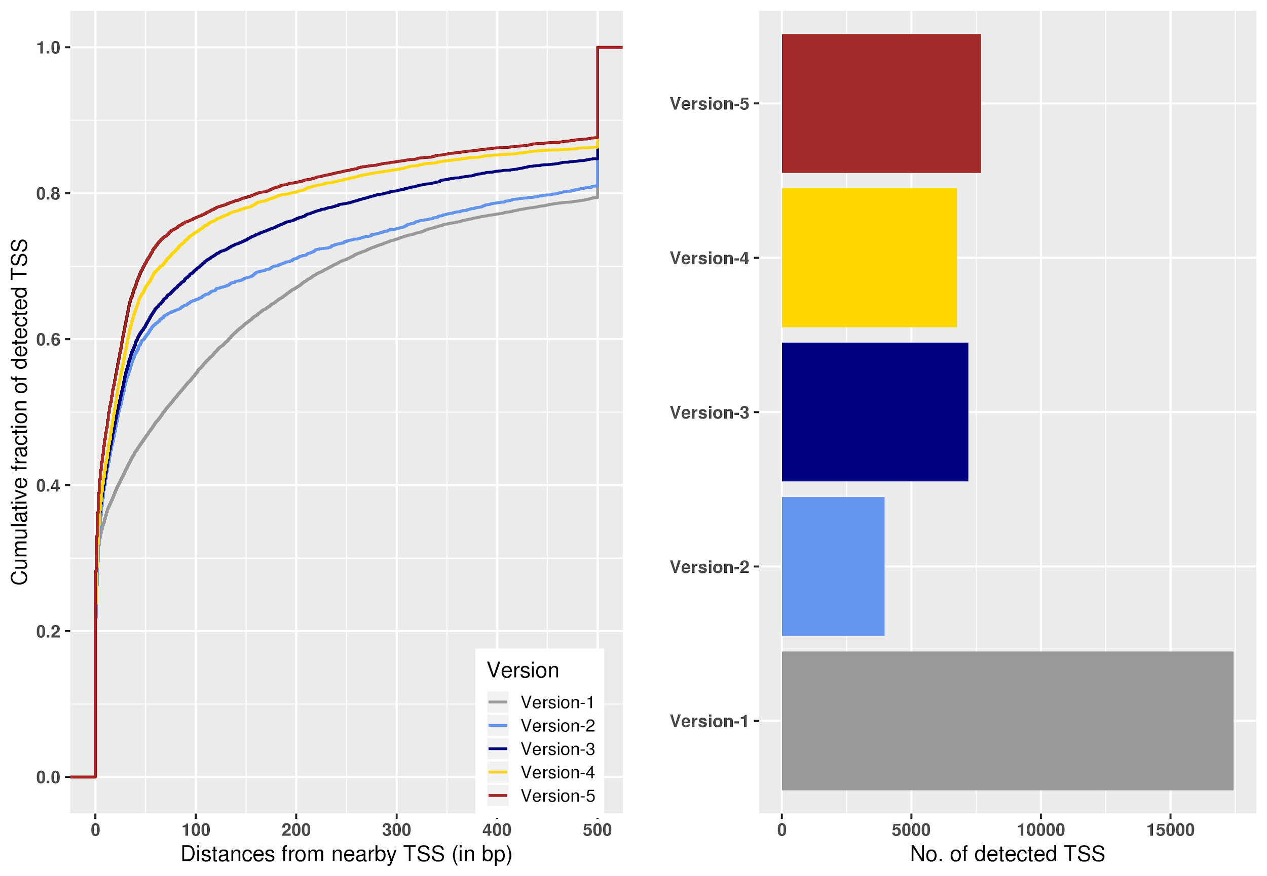

***Fig 3. Improvement in TSS detection over different versions of the MAPCap protocol*** *(not completely in chronological order).* ***Left :*** *Distance of detected TSS to an annotated TSS. As the protocol improved, the detected TSS became closes to the annotated TSS in the genome.* ***Right :*** *Number of detected TSS for each version. Version 1 has the highest number of detected TSSs, however the precision plot shows that it was mostly due to low signal-to-noise ratio. The number of detected TSSs remains constant for the later versions of the protocol while the precision improved. All samples utilized 5ug of RNA, and TSSs were detected in all samples using the “distclu” method with the same parameters.*

An important insight from the development of the protocol has been the effect of RNA composition bias on the final analysis. In case of protocols like MAPCap, that allow early multiplexing, the effect of composition bias is more pronounced, since there are multiple steps where high abundance RNA can “take over” the overall library composition.

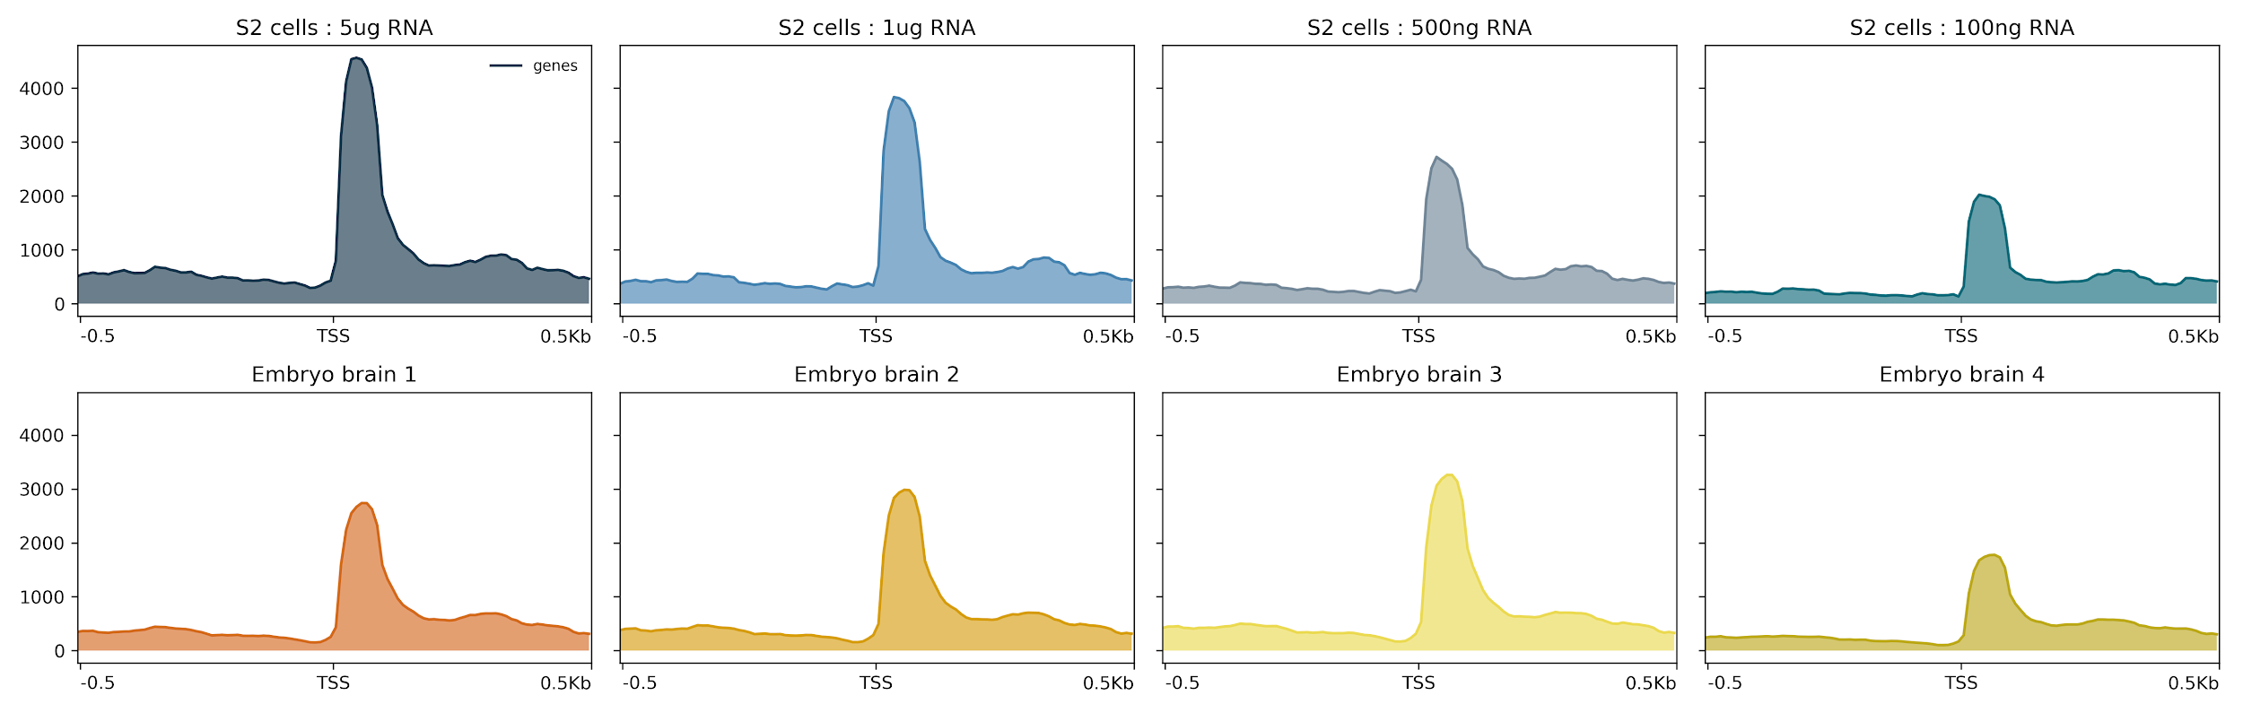

***Fig 4. Effect of RNA composition on TSS enrichment*** *(RPKM normalized signal on TSS).* ***Upper*** *panel shows the data from a MAPCap run where different input concentrations of RNA were multiplexed. Enrichment decreases as the amount of input RNA gets lower.* ***Lower*** *panel shows data from a MAPCap run where total RNA was extracted from different embryos brains. The concentration varies between 200-500 ng per sample. Lower panel represents a more practical MAPCap run, since the RNA composition couldn’t be precisely controlled.*

Promoter-profiling is usually performed on ribo-depleted RNA, and the RNA composition fluctuates for each run, especially for samples derived from tissues (Fig. 4). This emphasised the need for methods to account for composition bias (such as TMM [168](https://paperpile.com/c/7HQKXY/Tdpjl)), and the usefulness of replicates in the detection of robust TSSs in presence of noise.

### Development of the icetea bioconductor package

The new generation promoter-profiling protocols such as MAPCap, and the recently introduced RAMPAGE [157](https://paperpile.com/c/7HQKXY/TnrB8) protocol demand a set of data processing steps different from traditional CAGE. The raw FASTQ files obtained from the protocol contains sample multiplexing barcodes, which are used to separate the samples, and the random barcodes, which could be used to remove PCR duplicates during the analysis. The paired-end data produced by this protocol could be used to improve mapping and annotation of peaks. Also, multiplexing makes it easier for biologists to include biological replicates in their experiments, which could be useful in performing robust TSS detection and downstream analysis (see introduction). Also, a good correlation between expression estimates between MAPCap and RNA-seq suggested that after appropriate normalization, a MAPCap experiment with biological replicates could also be used for differential TSS expression analysis.

Keeping the above observations in mind, I created a user-friendly R package called **icetea** (**I**ntegrating **C**ap **E**nrichment and **T**ranscript **E**xpression **A**nalysis) that performs processing, TSS detection and differential expression analysis from data such as those from MAPCap and RAMPAGE. **Icetea** implements a new TSS detection approach based on “local enrichment” of CAGE tags, that’s inspired from ChIP-seq analysis. It uses replicates to model robust fold-changes of genomic windows with their local background, and a user-specified fold-change cutoff is used to detect TSS. Further, **icetea** can be used to perform various internal (TMM, RLE etc.) or external (spike-In) normalization of data and detect differentially expressed TSSs between two conditions. **Icetea** is available for use from bioconductor (<https://bioconductor.org/packages/icetea>).

### Transcriptional changes during dosage compensation defects in flies

In order to gain insights into transcript-specific dosage compensation in flies, we performed MAPCap, together with RNA-seq, on brains extracted from male and female fly larvae. RNAs were extracted from the mutants of the *maleless* (MLE) gene, which is required for the targeting of the MSL complex to X chromosome through recognition of roX RNAs. Therefore, mutant males are expected to have defects in the upregulation of the X-chromosome. We then deployed a processing pipeline based on icetea for the analysis (<https://github.com/vivekbhr/cage_pipeline>). Analysis showed that most promoters are similarly used between male and female flies. MLE KO leads to a downregulation of majority of TSSs on the X-chromosome in males ( >1700 downregulated TSSs), but have almost no effect on females (~23 TSSs differentially expressed). Very few (241) upregulated TSS were observed genome-wide, with only 14 on X-chromosome. Analysis of wild-type ChIP-seq data on the differentially expressed TSS showed that both up-regulated and unchanged TSS had similarly high H4K16ac levels which, while the up-regulated TSS showed low H4K16ac levels in both sexes. We are further generating H4K16ac ChIP-seq in MLE KO to investigate the TSS which remain unchanged upon MLE KO in the MAPCap data in order to understand whether their resistance to change in promoter usage is dependent on their H4K16ac levels.

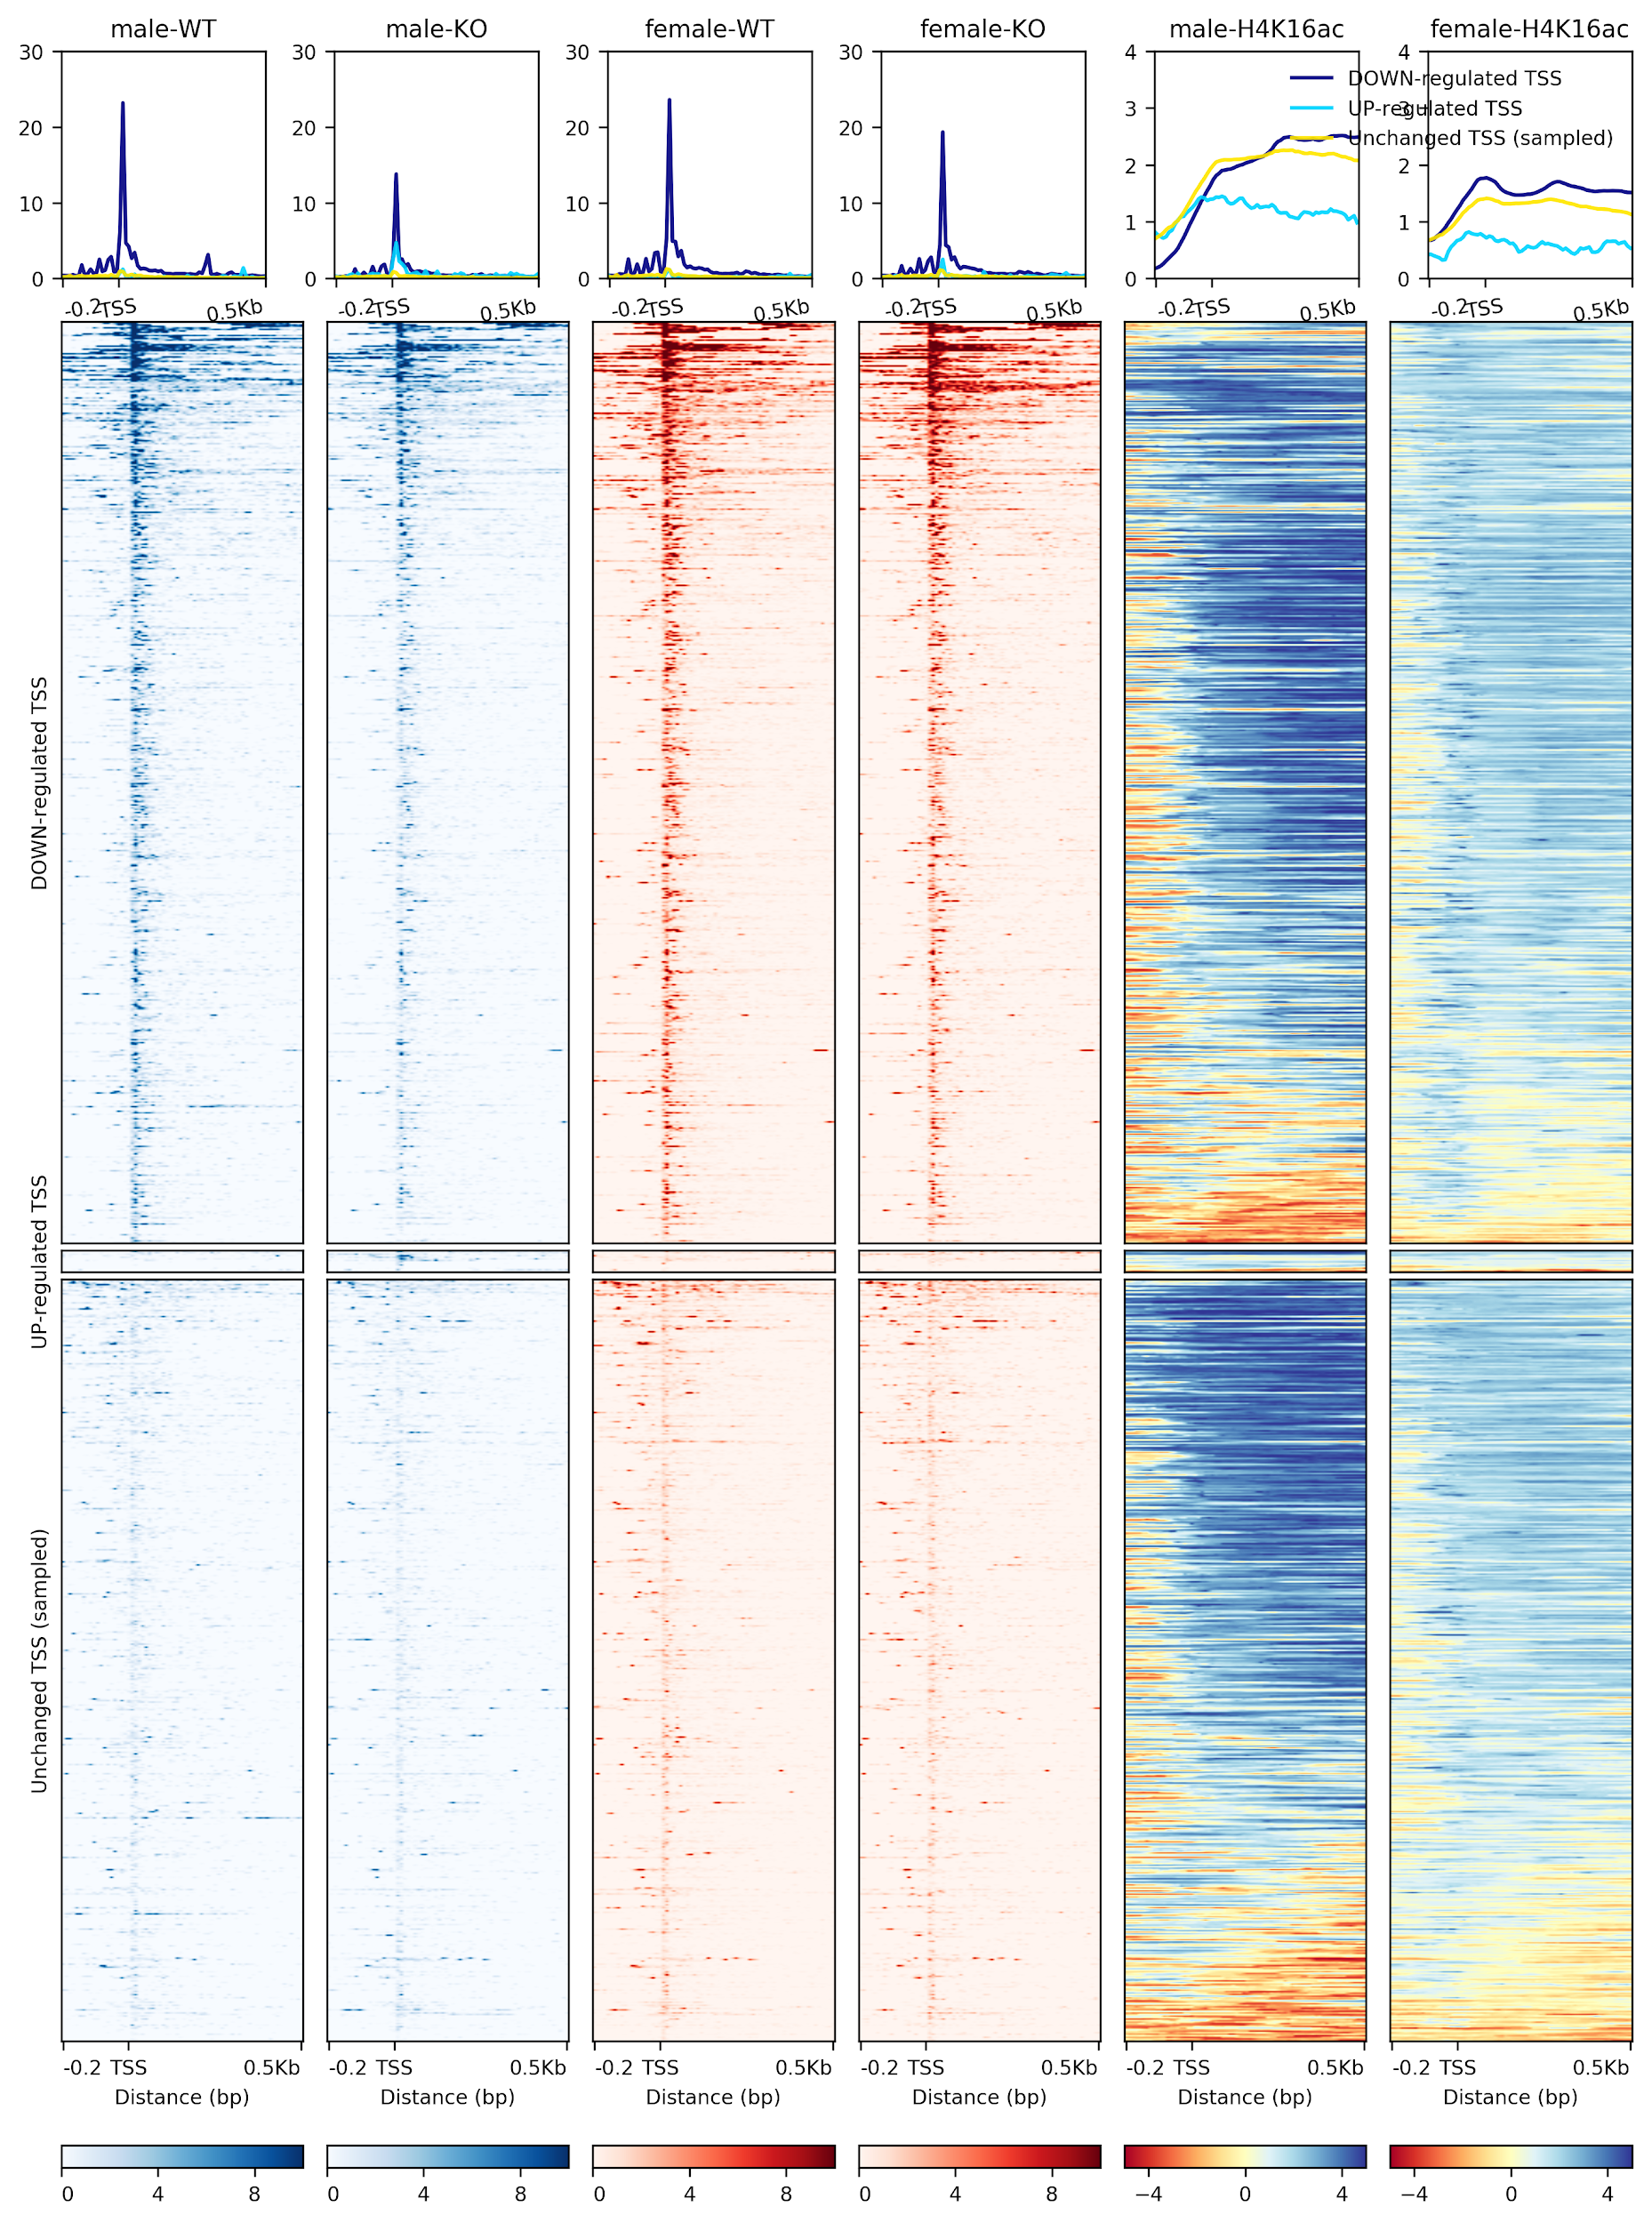

***Fig 5. TSS expression (MAPCap) and H4K16ac levels (ChIP-seq) on male and female embryo brains.*** *Upon KO of MLE, male brains show about ~2-fold downregulation, while female brains do not show a large change. Both downregulated and unchanged TSS have similar H4K16ac levels in wild-type cells (males have higher level than females on the X). The plot is made using an new version of deepTools* [*120*](https://paperpile.com/c/7HQKXY/KT1A) *that allow creation of coverage files and visualization of data from multiple assays together.*

## Integrating transcriptomic and epigenomic analysis to study MSLs in mammals

### The role of MSL complex member MLE in mammals

All MSL complex members except the roX RNAs, are conserved from *Drosophila* to mammals (see introduction) and previous study from our lab based on ChIP-seq of the MSLs discovered their genome-wide localization on gene promoters and enhancers [96](https://paperpile.com/c/7HQKXY/ajyuy). The role of the conserved homolog of MLE, termed as DHX9, was however not investigated in this study. To study the functions of the DHX9 RNA helicase, Tugce Aktas and Ibrahim Ilik in the lab performed an improved version of RNA-CLIP : a method used to determine RNA binding partners of a protein of interest. This method, termed UV-CLAP (Ultraviolet Cross Linking and Immunoprecipitation) produced genome-wide map of DHX9-RNA interactions, and the visual inspection of the data revealed that DHX9 seems to preferentially bind to human Alu elements in the genome.

In collaboration with Tugce and Ibrahim, I performed a genome-wide enrichment analysis of various Alu subfamilies in the DHX9 UV-CLAP data using two independent approaches : 1) consensus repeat mappings, followed by enrichment analysis (adopted from [169](https://paperpile.com/c/7HQKXY/P4aG)) and 2) graph-based clustering of raw DHX9 bound sequences (adopted from [170](https://paperpile.com/c/7HQKXY/fHYX)). Both approaches revealed a significant association of DHX9 with Alu repeats in humans, and their evolutionary relatives : B1 transposons in mice. DHX9 was preferentially enriched on young AluS and AluY families enriched in gene introns. To further investigate the role of DHX9-Alu interaction in introns, Ibrahim performed RNA-seq experiment with poly-A selected and poly-A depleted RNA. My analysis of this data revealed that DHX9 depletion leads to widespread defects in gene expression and splicing, and an increase in production of circular RNA species in the cell. Further, since intronic Alu elements are frequently associated with RNA editing [171–174](https://paperpile.com/c/7HQKXY/NhWGi+hsQLV+KjGds+ny9Gj), I developed a workflow for detection of RNA editing from the RNA-seq data (<https://github.com/vivekbhr/dhx-alu>). Using the workflow, we identified both an increase and decrease of RNA editing genome-wide, although RNA editing explained only a minor fraction of gene expression changes. Overall, this analysis revealed for the first time, that DHX9 has a major role in regulating RNA processing defects contributed by the Alu elements in the human genome [175](https://paperpile.com/c/7HQKXY/fj4uR).

### The role of MSL complex on active and inactive mammalian X chromosomes

Probing the function of the MSL complex in mammals, the previous study from our lab discovered that the differentiation of female mouse embryonic stem cells (ESCs) depleted for MSL complex members (MSL1 and MSL2) leads to chaotic inactivation of the X chromosome. A fraction of these differentiating neural progenitor cells (NPCs) showed both X chromosomes being inactivated [96](https://paperpile.com/c/7HQKXY/ajyuy). This effect of MSLs was attributed to their regulation of the Tsix promoter through H4K16ac. In order to further investigate the function of MSLs on the X chromosome, we sought to 1) generate genome-wide binding profiles of MSLs in female mouse cell lines 2) Investigate the effect of MSL loss in a system independent of Tsix effects.

Tomsaz Chelmicki therefore generated ChIP-seq profiles of MSLs in female ESCs and NPCs derived from a mouse strain of hybrid origin, a cross between *Mus musculus* (strain 129Sv) and *Mus castanious* (Cast) [176](https://paperpile.com/c/7HQKXY/IVDk9). To study effects independent of Tsix, Raed Hmadi generated KOs for MSL2 in the NPCs, where X-inactivation has already been established. We then generated RNA-seq profiles of these KO clones, along with the wild-type controls. Further, in collaboration with Laura Arrigoni and Ralf Gilsbach, we generated profiling of various histone marks using RELACS [177](https://paperpile.com/c/7HQKXY/GGdOA), open chromatin profiling using ATAC-seq [178](https://paperpile.com/c/7HQKXY/BKnZ5), and whole genome methylation profile using bisulfite-seq (WGBS) [179](https://paperpile.com/c/7HQKXY/lrXnJ) on wild-type and KO NPCs.

For analysis of these datasets we needed an approach of mapping and sorting of genomic alignments in an allele-specific manner. I utilized an approach that masks the positions of single nucleotide polymorphisms (SNPs) coming from parental strains in the reference genome before mapping, followed by sorting of unique allele-specific alignments. This method, implemented in the tool SNPsplit [180](https://paperpile.com/c/7HQKXY/j3Xzr), overcomes the “reference bias” : an issue that reads coming from a strain that’s genetically closer to the reference genome, would map better to the reference genome in absence of SNP masking [181](https://paperpile.com/c/7HQKXY/J3Kyb). Workflows for analysis of epigenomic data that could perform allele-specific sorting were developed (see next section) and applied for the analysis of MSL2 KOs.

Applying our analysis workflow to MSL2 ChIP-seq data revealed that after, but not before differentiation into NPCs, MSL2 binds to significantly more loci on the inactive X-chromosome (Xi), compared to the active X (Xa). Analysis of RNA-seq data revealed an allele-specific downregulation of genes associated with MSL2 binding, upon the loss of MSL2. However the loss on one allele-was compensated by a gain in expression from another allele. Analysis of ATAC-seq data in the KOs suggested that this effect is transcriptional, since the promoters associated with loss of expression show a loss of open chromatin and vice-versa (Fig. 5). This analysis suggests that MSL2 might be important for maintaining allelic balance of expression of their target genes. Further, there seems to be an allelic-sensing mechanism on the chromosome that compensates for the loss of MSL2 on the target allele. Further integrative analysis of this data to understand the effects of MSLs on the X chromosome is underway.

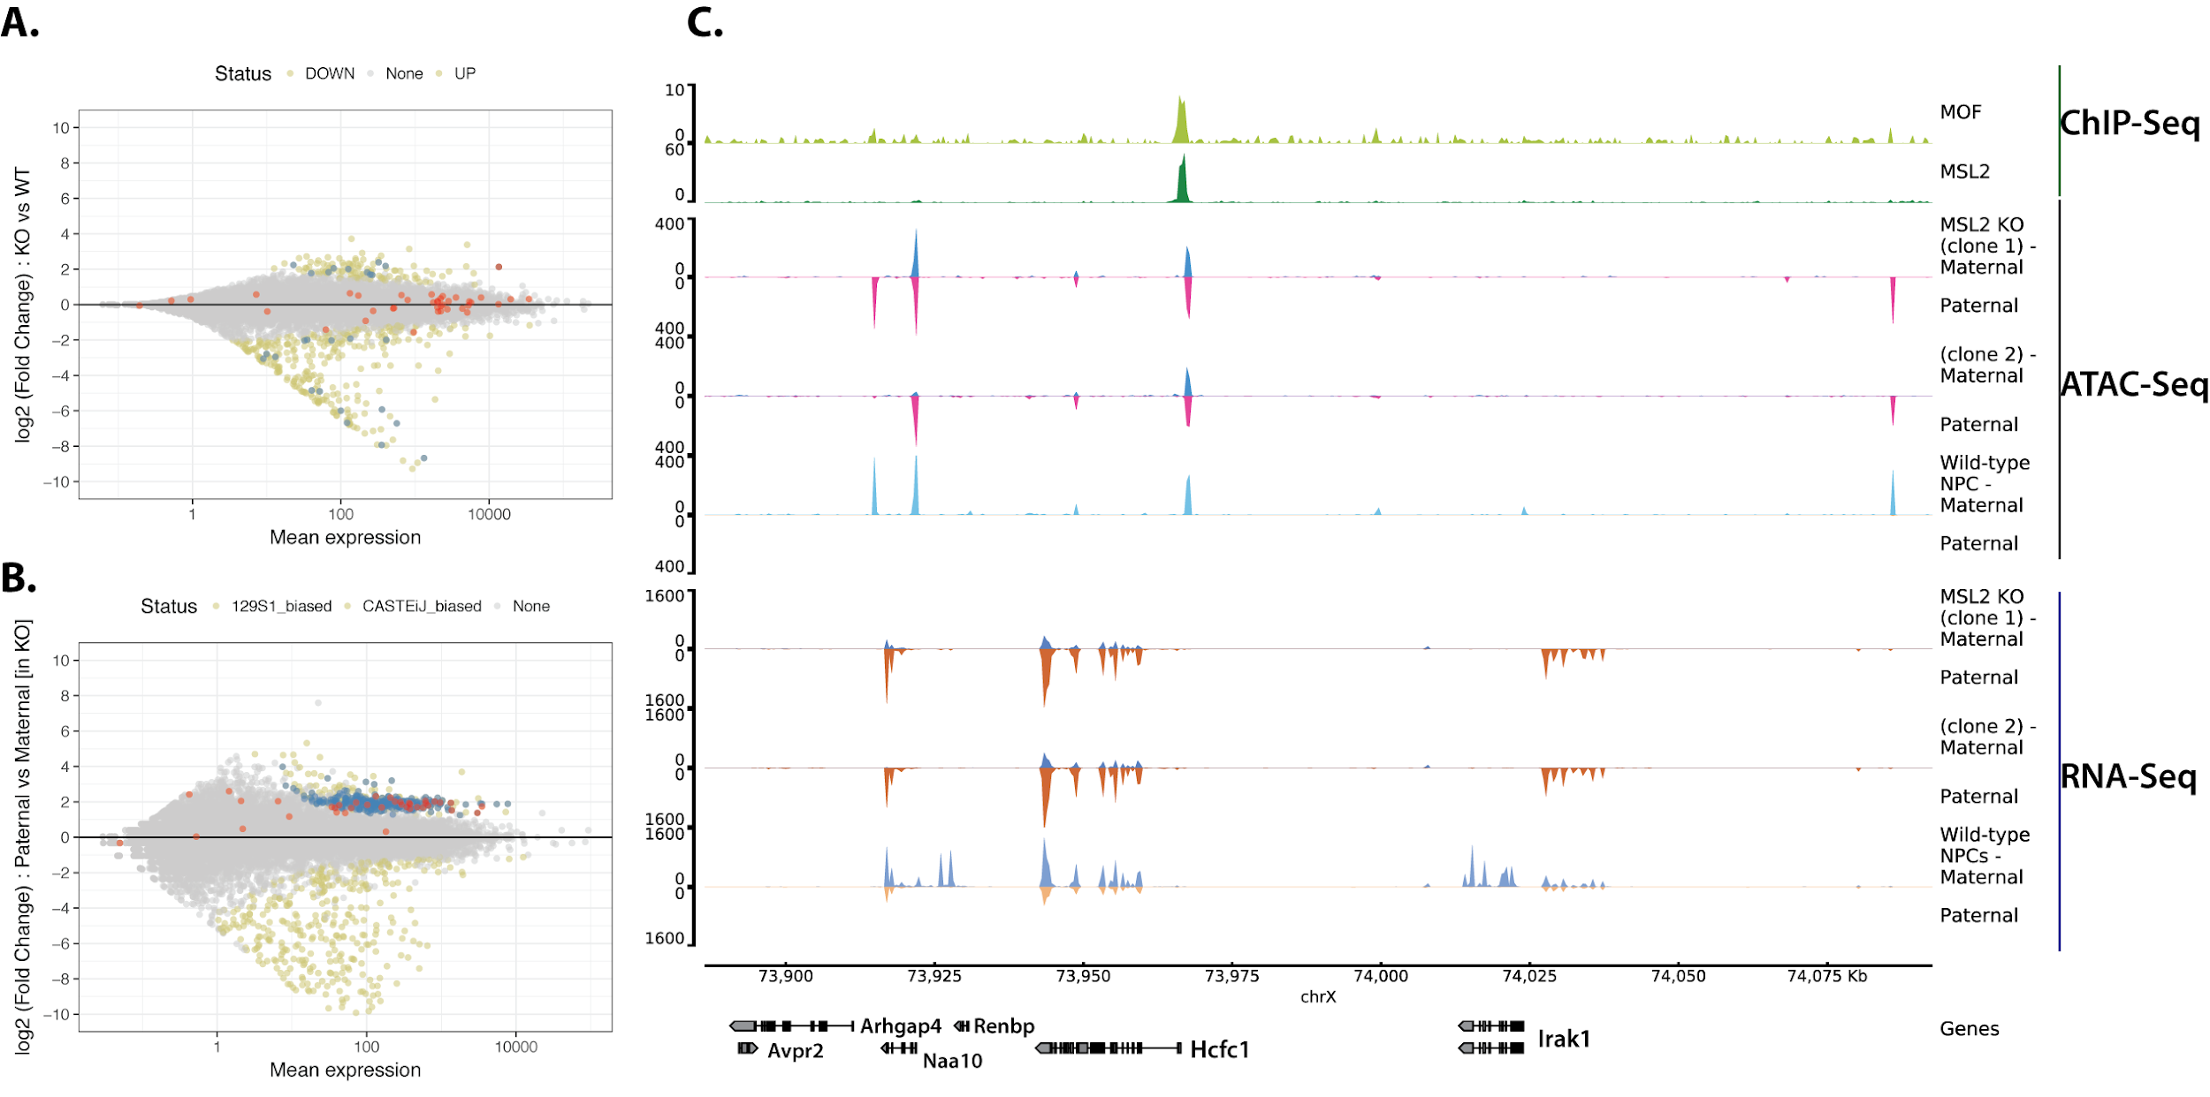

***Fig 5. Integrative analysis of ChIP-Seq, RNA-Seq and ATAC-Seq in MSL2 knockout (KO) NPCs.******A)*** *The MSL2 bound genes on X-chromosome (marked in red) seem to be unaffected in normal RNA-seq analysis. Genes differentially expressed between KO and Wild-type cells are marked in green, and affected genes on chrX are marked in blue* ***B)*** *Allele-specific analysis of the data reveals that genes on chrX show a clear bias in expression towards the paternal allele (blue). Many of these genes are bound by MSL2 at their promoters (red).* ***C)*** *Genome browser track showing a locus with escapees of Xi, MSL2 KO shows activation of paternal allele expression, concordant with open chromatin changes.*

### A toolkit for integrative epigenomic analysis

The analysis of various epigenomic datasets described in the section above is a massive challenge for a single bioinformatician, and demands a set of uniform processing pipelines. We sought to develop a pipeline that would also allow flexible processing of datasets such that future users are able to change parameters and perform exploratory analysis. This pipeline should be scalable, to run hundreds to thousands of jobs at once, and should be easy to install and use for future. I joined the existing efforts by Steffen Heyne and others in the bioinformatics unit to develop a toolkit that allows analysis of ChIP-seq, RNA-seq, ATAC-seq, WGBS, Hi-C and single cell RNA-seq data. This toolkit, called **snakePipes**, implements various methods and workflows described in the previous sections, in a user-friendly command-line interface. The pipeline also performs allele-specific analysis of data as described in the previous section, upto the point of downstream analysis, such as differential expression of differential peak detection. With snakePipes, we hope that biologists would be able to easily replicate the results from ours and other online studies that present multiple epigenomic assays [182](https://paperpile.com/c/7HQKXY/9tjSA).

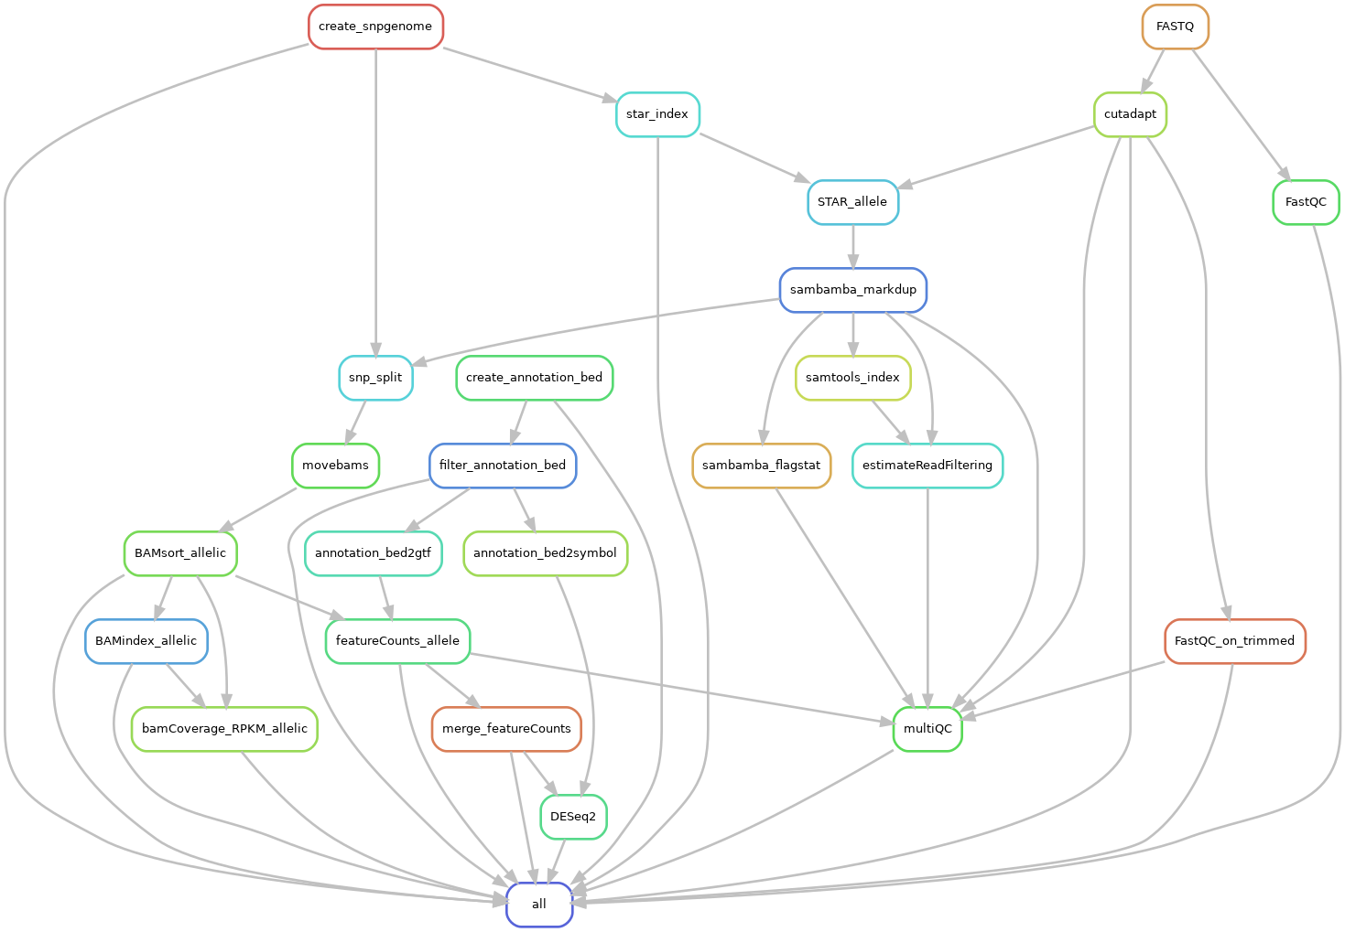

***Fig. 6.* *A directed acyclic graph (DAG) of the allele-specific RNA-seq analysis workflow.*** *The workflow begins with creation of dual-hybrid genomes for user-defined strains of interest, and ends with allele-specific differential expression analysis using a statistical interaction based design. Optional quality-checks can be performed via deepTools* [*120*](https://paperpile.com/c/7HQKXY/KT1A) *(not displayed here for clarity). This workflow has been implemented in snakePipes.*

## Conclusion and Outlook

Various elements in eukaryotic genome, such as DNA sequences, chromatin and the 3D topological structure act together to facilitate gene regulation. Therefore, Integrative transcriptomic and epigenomic analysis is becoming an important tool to understand genomic regulation. In this project, I performed analysis of various transcriptomic and epigenomic assays in order to understand the function of members of the MSL complex, from flies to humans. To facilitate this, we developed bioinformatic tools and workflows for analysis of transcription, histone marks and 3D conformation of the genome. Application of our methods revealed a catalogue of high-resolution boundaries in flies and their effect on transcription, the role of MSL complex member MLE and H4K16ac in promoter usage in male flies, the newly evolved function of MLE ortholog DHX9 in mammals, and finally an interesting new insight into the role of the mammalian MSL complex on the X-chromosome.

Future directions in studying MSLs would benefit from further integration of data. For example, since most TAD boundaries in flies are associated with promoters, an integration of 3D conformation and promoter-profiling data could reveal the mechanism of how gene-by-gene dosage compensation could be established at early embryogenesis via the spreading of MSL-complex on X. Further, it It would be interesting to explore the role of chromosome conformation in other scenarios, such as the recently observed targeting of MSL2 on autosomes [183](https://paperpile.com/c/7HQKXY/SZBv). Unlike well studied functions of MSLs in *Drosophila*, we have only recently started to understand the role MSLs in mammals, and in particular, its difference with the role of another MOF associated complex, the NSLs. Rigorously designed ChIP-seq experiments in presence of MSL and NSL knockout controls would be required to avoid antibody non-specificity as well as to study the dependence of MSL targeting on the NSL complex. Our understanding of the role of H4K16ac in mammals would also be improved by studying its relationship with other histone marks. Performing a full histone profiling upon MSL and NSL depletion would be relatively simpler now due to the development of highly multiplexed protocols [110](https://paperpile.com/c/7HQKXY/F5Op), enabling future studies would be able to tackle such question. Further, development of technologies performing low-cell or single cell epigenomics has provided new scope to study MSL biology in tissues during development and differentiation. Methods for analysis of such assays are yet in their infancy, and therefore would present interesting challenges to work on, in the near future.

## References

1. [Crick, F. Central dogma of molecular biology. *Nature* **227,** 561–563 (1970).](http://paperpile.com/b/7HQKXY/M0eAi)

2. [Epp, C. D. Definition of a gene. *Nature* **389,** 537 (1997).](http://paperpile.com/b/7HQKXY/3QS1S)

3. [Gerstein, M. B. *et al.* What is a gene, post-ENCODE? History and updated definition. *Genome Res.* **17,** 669–681 (2007).](http://paperpile.com/b/7HQKXY/Zooup)

4. [Berthelot, C., Villar, D., Horvath, J. E., Odom, D. T. & Flicek, P. Complexity and conservation of regulatory landscapes underlie evolutionary resilience of mammalian gene expression. *Nat Ecol Evol* **2,** 152–163 (2018).](http://paperpile.com/b/7HQKXY/l02kG)

5. [Villegas, V. E. & Zaphiropoulos, P. G. Neighboring gene regulation by antisense long non-coding RNAs. *Int. J. Mol. Sci.* **16,** 3251–3266 (2015).](http://paperpile.com/b/7HQKXY/UpD8U)

6. [Catalanotto, C., Cogoni, C. & Zardo, G. MicroRNA in Control of Gene Expression: An Overview of Nuclear Functions. *Int. J. Mol. Sci.* **17,** (2016).](http://paperpile.com/b/7HQKXY/66Wvh)

7. [Engreitz, J. M., Ollikainen, N. & Guttman, M. Long non-coding RNAs: spatial amplifiers that control nuclear structure and gene expression. *Nat. Rev. Mol. Cell Biol.* **17,** 756–770 (2016).](http://paperpile.com/b/7HQKXY/RFgcA)

8. [Siomi, H. & Dreyfuss, G. RNA-binding proteins as regulators of gene expression. *Curr. Opin. Genet. Dev.* **7,** 345–353 (1997).](http://paperpile.com/b/7HQKXY/H09HK)

9. [Berger, S. L., Kouzarides, T., Shiekhattar, R. & Shilatifard, A. An operational definition of epigenetics. *Genes Dev.* **23,** 781–783 (2009).](http://paperpile.com/b/7HQKXY/gicXl)

10. [Shendure, J. *et al.* Accurate multiplex polony sequencing of an evolved bacterial genome. *Science* **309,** 1728–1732 (2005).](http://paperpile.com/b/7HQKXY/IFg2j)

11. [Schuster, S. C. Next-generation sequencing transforms today’s biology. *Nat. Methods* **5,** 16–18 (2008).](http://paperpile.com/b/7HQKXY/UaaXw)

12. [Griffiths, P. E. In what sense does ‘nothing make sense except in the light of evolution’? *Acta Biotheor.* **57,** 11–32 (2009).](http://paperpile.com/b/7HQKXY/ML9gI)

13. [Mouse Genome Sequencing Consortium *et al.* Initial sequencing and comparative analysis of the mouse genome. *Nature* **420,** 520–562 (2002).](http://paperpile.com/b/7HQKXY/lIZg1)

14. [Church, D. M. *et al.* Lineage-specific biology revealed by a finished genome assembly of the mouse. *PLoS Biol.* **7,** e1000112 (2009).](http://paperpile.com/b/7HQKXY/7auK6)

15. [Rands, C. M., Meader, S., Ponting, C. P. & Lunter, G. 8.2% of the Human genome is constrained: variation in rates of turnover across functional element classes in the human lineage. *PLoS Genet.* **10,** e1004525 (2014).](http://paperpile.com/b/7HQKXY/epOGn)

16. [Graur, D. An Upper Limit on the Functional Fraction of the Human Genome. *Genome Biol. Evol.* **9,** 1880–1885 (2017).](http://paperpile.com/b/7HQKXY/fjAZ6)

17. [ENCODE Project Consortium. An integrated encyclopedia of DNA elements in the human genome. *Nature* **489,** 57–74 (2012).](http://paperpile.com/b/7HQKXY/mU5yX)

18. [Riethoven, J.-J. M. Regulatory Regions in DNA: Promoters, Enhancers, Silencers, and Insulators. in *Computational Biology of Transcription Factor Binding* (ed. Ladunga, I.) 33–42 (Humana Press, 2010).](http://paperpile.com/b/7HQKXY/Cj5ky)

19. [Huang, H., Sabari, B. R., Garcia, B. A., Allis, C. D. & Zhao, Y. SnapShot: histone modifications. *Cell* **159,** 458–458.e1 (2014).](http://paperpile.com/b/7HQKXY/1exNO)

20. [Fuhrmann, G. *et al.* Mouse germline restriction of Oct4 expression by germ cell nuclear factor. *Dev. Cell* **1,** 377–387 (2001).](http://paperpile.com/b/7HQKXY/xq96n)

21. [Feldman, N. *et al.* G9a-mediated irreversible epigenetic inactivation of Oct-3/4 during early embryogenesis. *Nat. Cell Biol.* **8,** 188–194 (2006).](http://paperpile.com/b/7HQKXY/xbVfG)

22. [Smallwood, A. & Ren, B. Genome organization and long-range regulation of gene expression by enhancers. *Curr. Opin. Cell Biol.* **25,** 387–394 (2013).](http://paperpile.com/b/7HQKXY/qjCrb)

23. [Cullen, K. E., Kladde, M. P. & Seyfred, M. A. Interaction between transcription regulatory regions of prolactin chromatin. *Science* **261,** 203–206 (1993).](http://paperpile.com/b/7HQKXY/uJfV1)

24. [Lieberman-Aiden, E. *et al.* Comprehensive mapping of long-range interactions reveals folding principles of the human genome. *Science* **326,** 289–293 (2009).](http://paperpile.com/b/7HQKXY/lrwqn)

25. [Dixon, J. R. *et al.* Topological domains in mammalian genomes identified by analysis of chromatin interactions. *Nature* **485,** 376–380 (2012).](http://paperpile.com/b/7HQKXY/5Lm8o)

26. [Rao, S. S. P. *et al.* A 3D map of the human genome at kilobase resolution reveals principles of chromatin looping. *Cell* **159,** 1665–1680 (2014).](http://paperpile.com/b/7HQKXY/CokeH)

27. [Dixon, J. R., Gorkin, D. U. & Ren, B. Chromatin Domains: The Unit of Chromosome Organization. *Mol. Cell* **62,** 668–680 (2016).](http://paperpile.com/b/7HQKXY/YDcIe)

28. [Phillips-Cremins, J. E. & Corces, V. G. Chromatin insulators: linking genome organization to cellular function. *Mol. Cell* **50,** 461–474 (2013).](http://paperpile.com/b/7HQKXY/3xOT4)

29. [de Laat, W. & Duboule, D. Topology of mammalian developmental enhancers and their regulatory landscapes. *Nature* **502,** 499–506 (2013).](http://paperpile.com/b/7HQKXY/XJABO)

30. [Vietri Rudan, M. *et al.* Comparative Hi-C reveals that CTCF underlies evolution of chromosomal domain architecture. *Cell Rep.* **10,** 1297–1309 (2015).](http://paperpile.com/b/7HQKXY/NkaRy)

31. [Phillips, J. E. & Corces, V. G. CTCF: master weaver of the genome. *Cell* **137,** 1194–1211 (2009).](http://paperpile.com/b/7HQKXY/XAkfG)

32. [Nicodemi, M. & Pombo, A. Models of chromosome structure. *Curr. Opin. Cell Biol.* **28,** 90–95 (2014).](http://paperpile.com/b/7HQKXY/Bby5g)

33. [Alipour, E. & Marko, J. F. Self-organization of domain structures by DNA-loop-extruding enzymes. *Nucleic Acids Res.* **40,** 11202–11212 (2012).](http://paperpile.com/b/7HQKXY/mc3v5)

34. [Sanborn, A. L. *et al.* Chromatin extrusion explains key features of loop and domain formation in wild-type and engineered genomes. *Proc. Natl. Acad. Sci. U. S. A.* **112,** E6456–65 (2015).](http://paperpile.com/b/7HQKXY/YHgjj)

35. [Yardımcı, G. G. & Noble, W. S. Predictive model of 3D domain formation via CTCF-mediated extrusion. *Proc. Natl. Acad. Sci. U. S. A.* **112,** 14404–14405 (2015).](http://paperpile.com/b/7HQKXY/FaWNu)

36. [Fudenberg, G. *et al.* Formation of Chromosomal Domains by Loop Extrusion. *Cell Rep.* **15,** 2038–2049 (2016).](http://paperpile.com/b/7HQKXY/dcnf2)

37. [Goloborodko, A., Marko, J. F. & Mirny, L. A. Chromosome Compaction by Active Loop Extrusion. *Biophys. J.* **110,** 2162–2168 (2016).](http://paperpile.com/b/7HQKXY/lTXYt)

38. [Nuebler, J., Fudenberg, G., Imakaev, M., Abdennur, N. & Mirny, L. A. Chromatin organization by an interplay of loop extrusion and compartmental segregation. *Proc. Natl. Acad. Sci. U. S. A.* **115,** E6697–E6706 (2018).](http://paperpile.com/b/7HQKXY/7nd7W)

39. [Nora, E. P. *et al.* Targeted Degradation of CTCF Decouples Local Insulation of Chromosome Domains from Genomic Compartmentalization. *Cell* **169,** 930–944.e22 (2017).](http://paperpile.com/b/7HQKXY/ShlAF)

40. [Rao, S. S. P. *et al.* Cohesin Loss Eliminates All Loop Domains. *Cell* **171,** 305–320.e24 (2017).](http://paperpile.com/b/7HQKXY/oqIL4)

41. [Haarhuis, J. H. I. *et al.* The Cohesin Release Factor WAPL Restricts Chromatin Loop Extension. *Cell* **169,** 693–707.e14 (2017).](http://paperpile.com/b/7HQKXY/WMyxa)

42. [Richterova, J., Huraiova, B. & Gregan, J. Genome Organization: Cohesin on the Move. *Mol. Cell* **66,** 444–445 (2017).](http://paperpile.com/b/7HQKXY/D3uUs)

43. [Terakawa, T. *et al.* The condensin complex is a mechanochemical motor that translocates along DNA. *Science* **358,** 672–676 (2017).](http://paperpile.com/b/7HQKXY/tapyh)

44. [Ganji, M. *et al.* Real-time imaging of DNA loop extrusion by condensin. *Science* **360,** 102–105 (2018).](http://paperpile.com/b/7HQKXY/mVXNz)

45. [Stigler, J., Çamdere, G. Ö., Koshland, D. E. & Greene, E. C. Single-Molecule Imaging Reveals a Collapsed Conformational State for DNA-Bound Cohesin. *Cell Rep.* **15,** 988–998 (2016).](http://paperpile.com/b/7HQKXY/Wmjx4)

46. [Ulianov, S. V. *et al.* Active chromatin and transcription play a key role in chromosome partitioning into topologically associating domains. *Genome Res.* **26,** 70–84 (2016).](http://paperpile.com/b/7HQKXY/qPVL9)

47. [Hug, C. B., Grimaldi, A. G., Kruse, K. & Vaquerizas, J. M. Chromatin Architecture Emerges during Zygotic Genome Activation Independent of Transcription. *Cell* **169,** 216–228.e19 (2017).](http://paperpile.com/b/7HQKXY/GYHR)

48. [Heinz, S. *et al.* Transcription Elongation Can Affect Genome 3D Structure. *Cell* **174,** 1522–1536.e22 (2018).](http://paperpile.com/b/7HQKXY/SqUjd)

49. [Graves, J. A. M. Evolution of vertebrate sex chromosomes and dosage compensation. *Nat. Rev. Genet.* **17,** 33–46 (2016).](http://paperpile.com/b/7HQKXY/D7RQk)

50. [Okamoto, I., Otte, A. P., Allis, C. D., Reinberg, D. & Heard, E. Epigenetic dynamics of imprinted X inactivation during early mouse development. *Science* **303,** 644–649 (2004).](http://paperpile.com/b/7HQKXY/bXnck)

51. [Escamilla-Del-Arenal, M., da Rocha, S. T. & Heard, E. Evolutionary diversity and developmental regulation of X-chromosome inactivation. *Hum. Genet.* **130,** 307–327 (2011).](http://paperpile.com/b/7HQKXY/BqVAL)

52. [Martin, G. R. *et al.* X–chromosome inactivation during differentiation of female teratocarcinoma stem cells in vitro. *Nature* **271,** 329 (1978).](http://paperpile.com/b/7HQKXY/fKUSW)

53. [Augui, S. *et al.* Sensing X chromosome pairs before X inactivation via a novel X-pairing region of the Xic. *Science* **318,** 1632–1636 (2007).](http://paperpile.com/b/7HQKXY/F1Cso)

54. [Barakat, T. S. *et al.* RNF12 activates Xist and is essential for X chromosome inactivation. *PLoS Genet.* **7,** e1002001 (2011).](http://paperpile.com/b/7HQKXY/TfuOH)

55. [Navarro, P. *et al.* Molecular coupling of Tsix regulation and pluripotency. *Nature* **468,** 457–460 (2010).](http://paperpile.com/b/7HQKXY/RsePt)

56. [Navarro, P., Moffat, M., Mullin, N. P. & Chambers, I. The X-inactivation trans-activator Rnf12 is negatively regulated by pluripotency factors in embryonic stem cells. *Hum. Genet.* **130,** 255–264 (2011).](http://paperpile.com/b/7HQKXY/XPGjC)

57. [Galupa, R. & Heard, E. X-chromosome inactivation: new insights into cis and trans regulation. *Curr. Opin. Genet. Dev.* **31,** 57–66 (2015).](http://paperpile.com/b/7HQKXY/qmbTG)

58. [Masui, O. *et al.* Live-cell chromosome dynamics and outcome of X chromosome pairing events during ES cell differentiation. *Cell* **145,** 447–458 (2011).](http://paperpile.com/b/7HQKXY/vPJgU)

59. [Navarro, P., Pichard, S., Ciaudo, C., Avner, P. & Rougeulle, C. Tsix transcription across the Xist gene alters chromatin conformation without affecting Xist transcription: implications for X-chromosome inactivation. *Genes Dev.* **19,** 1474–1484 (2005).](http://paperpile.com/b/7HQKXY/QVTdV)

60. [Jeppesen, P. & Turner, B. M. The inactive X chromosome in female mammals is distinguished by a lack of histone H4 acetylation, a cytogenetic marker for gene expression. *Cell* **74,** 281–289 (1993).](http://paperpile.com/b/7HQKXY/u3KSf)

61. [Heard, E. *et al.* Methylation of histone H3 at Lys-9 is an early mark on the X chromosome during X inactivation. *Cell* **107,** 727–738 (2001).](http://paperpile.com/b/7HQKXY/PvhvU)

62. [Chaumeil, J., Okamoto, I., Guggiari, M. & Heard, E. Integrated kinetics of X chromosome inactivation in differentiating embryonic stem cells. *Cytogenet. Genome Res.* **99,** 75–84 (2002).](http://paperpile.com/b/7HQKXY/jh1Br)

63. [da Rocha, S. T. *et al.* Jarid2 Is Implicated in the Initial Xist-Induced Targeting of PRC2 to the Inactive X Chromosome. *Mol. Cell* **53,** 301–316 (2014).](http://paperpile.com/b/7HQKXY/3bfqN)

64. [Chaumeil, J., Le Baccon, P., Wutz, A. & Heard, E. A novel role for Xist RNA in the formation of a repressive nuclear compartment into which genes are recruited when silenced. *Genes Dev.* **20,** 2223–2237 (2006).](http://paperpile.com/b/7HQKXY/REm4n)

65. [Rego, A., Sinclair, P. B., Tao, W., Kireev, I. & Belmont, A. S. The facultative heterochromatin of the inactive X chromosome has a distinctive condensed ultrastructure. *J. Cell Sci.* **121,** 1119–1127 (2008).](http://paperpile.com/b/7HQKXY/LNIOr)

66. [Engreitz, J. M. *et al.* The Xist lncRNA exploits three-dimensional genome architecture to spread across the X chromosome. *Science* **341,** 1237973 (2013).](http://paperpile.com/b/7HQKXY/k5z8j)

67. [Simon, M. D. *et al.* High-resolution Xist binding maps reveal two-step spreading during X-chromosome inactivation. *Nature* **504,** 465–469 (2013).](http://paperpile.com/b/7HQKXY/Dzf36)

68. [Giorgetti, L. *et al.* Structural organization of the inactive X chromosome in the mouse. *Nature* **535,** 575–579 (2016).](http://paperpile.com/b/7HQKXY/HP27i)

69. [Wang, C.-Y., Jégu, T., Chu, H.-P., Oh, H. J. & Lee, J. T. SMCHD1 Merges Chromosome Compartments and Assists Formation of Super-Structures on the Inactive X. *Cell* **174,** 406–421.e25 (2018).](http://paperpile.com/b/7HQKXY/MeCuS)

70. [Lucchesi, J. C. & Kuroda, M. I. Dosage compensation in Drosophila. *Cold Spring Harb. Perspect. Biol.* **7,** (2015).](http://paperpile.com/b/7HQKXY/eWxtZ)

71. [Hilfiker, A., Hilfiker-Kleiner, D., Pannuti, A. & Lucchesi, J. C. mof, a putative acetyl transferase gene related to the Tip60 and MOZ human genes and to the SAS genes of yeast, is required for dosage compensation in Drosophila. *EMBO J.* **16,** 2054–2060 (1997).](http://paperpile.com/b/7HQKXY/TzC0p)

72. [Franke, A. & Baker, B. S. The rox1 and rox2 RNAs are essential components of the compensasome, which mediates dosage compensation in Drosophila. *Mol. Cell* **4,** 117–122 (1999).](http://paperpile.com/b/7HQKXY/GA1F1)

73. [Li, F., Schiemann, A. H. & Scott, M. J. Incorporation of the noncoding roX RNAs alters the chromatin-binding specificity of the Drosophila MSL1/MSL2 complex. *Mol. Cell. Biol.* **28,** 1252–1264 (2008).](http://paperpile.com/b/7HQKXY/UTFQg)

74. [Fauth, T., Müller-Planitz, F., König, C., Straub, T. & Becker, P. B. The DNA binding CXC domain of MSL2 is required for faithful targeting the Dosage Compensation Complex to the X chromosome. *Nucleic Acids Res.* **38,** 3209–3221 (2010).](http://paperpile.com/b/7HQKXY/IyTEP)

75. [Villa, R., Schauer, T., Smialowski, P., Straub, T. & Becker, P. B. PionX sites mark the X chromosome for dosage compensation. *Nature* **537,** 244–248 (2016).](http://paperpile.com/b/7HQKXY/bm3cr)

76. [Hallacli, E. *et al.* Msl1-mediated dimerization of the dosage compensation complex is essential for male X-chromosome regulation in Drosophila. *Mol. Cell* **48,** 587–600 (2012).](http://paperpile.com/b/7HQKXY/roVdr)

77. [Buscaino, A. *et al.* MOF-regulated acetylation of MSL-3 in the Drosophila dosage compensation complex. *Mol. Cell* **11,** 1265–1277 (2003).](http://paperpile.com/b/7HQKXY/tLmAV)

78. [Sural, T. H. *et al.* The MSL3 chromodomain directs a key targeting step for dosage compensation of the Drosophila melanogaster X chromosome. *Nat. Struct. Mol. Biol.* **15,** 1318–1325 (2008).](http://paperpile.com/b/7HQKXY/lHvCp)

79. [Meller, V. H. *et al.* Ordered assembly of roX RNAs into MSL complexes on the dosage-compensated X chromosome in Drosophila. *Curr. Biol.* **10,** 136–143 (2000).](http://paperpile.com/b/7HQKXY/faj6B)

80. [Kelley, R. L. *et al.* Epigenetic spreading of the Drosophila dosage compensation complex from roX RNA genes into flanking chromatin. *Cell* **98,** 513–522 (1999).](http://paperpile.com/b/7HQKXY/EK5s3)

81. [Akhtar, A. & Becker, P. B. Activation of transcription through histone H4 acetylation by MOF, an acetyltransferase essential for dosage compensation in Drosophila. *Mol. Cell* **5,** 367–375 (2000).](http://paperpile.com/b/7HQKXY/85FQZ)

82. [Conrad, T., Cavalli, F. M. G., Vaquerizas, J. M., Luscombe, N. M. & Akhtar, A. Drosophila dosage compensation involves enhanced Pol II recruitment to male X-linked promoters. *Science* **337,** 742–746 (2012).](http://paperpile.com/b/7HQKXY/0UgUN)

83. [Larschan, E. *et al.* X chromosome dosage compensation via enhanced transcriptional elongation in Drosophila. *Nature* **471,** 115–118 (2011).](http://paperpile.com/b/7HQKXY/YJVV4)

84. [Ferrari, F. *et al.* ‘Jump Start and Gain’ Model for Dosage Compensation in Drosophila Based on Direct Sequencing of Nascent Transcripts. *Cell Rep.* **5,** 629–636 (2013).](http://paperpile.com/b/7HQKXY/vPQfC)

85. [Ramírez, F. *et al.* High-Affinity Sites Form an Interaction Network to Facilitate Spreading of the MSL Complex across the X Chromosome in Drosophila. *Mol. Cell* **60,** 146–162 (2015).](http://paperpile.com/b/7HQKXY/NSQiJ)

86. [Schauer, T. *et al.* Chromosome topology guides the Drosophila Dosage Compensation Complex for target gene activation. *EMBO Rep.* (2017). doi:](http://paperpile.com/b/7HQKXY/P4EQM)[10.15252/embr.201744292](http://dx.doi.org/10.15252/embr.201744292)

87. [Berletch, J. B., Yang, F., Xu, J., Carrel, L. & Disteche, C. M. Genes that escape from X inactivation. *Hum. Genet.* **130,** 237–245 (2011).](http://paperpile.com/b/7HQKXY/0oeKB)

88. [Samata, M. & Akhtar, A. Dosage Compensation of the X Chromosome: A Complex Epigenetic Assignment Involving Chromatin Regulators and Long Noncoding RNAs. *Annu. Rev. Biochem.* **87,** 323–350 (2018).](http://paperpile.com/b/7HQKXY/2VfjG)

89. [Smith, E. R. *et al.* A human protein complex homologous to the Drosophila MSL complex is responsible for the majority of histone H4 acetylation at lysine 16. *Mol. Cell. Biol.* **25,** 9175–9188 (2005).](http://paperpile.com/b/7HQKXY/msbVl)

90. [Rea, S., Xouri, G. & Akhtar, A. Males absent on the first (MOF): from flies to humans. *Oncogene* **26,** 5385–5394 (2007).](http://paperpile.com/b/7HQKXY/oFsHq)

91. [Nguyen, D. K. & Disteche, C. M. Dosage compensation of the active X chromosome in mammals. *Nat. Genet.* **38,** 47–53 (2006).](http://paperpile.com/b/7HQKXY/N3hW)

92. [Deng, X. *et al.* Evidence for compensatory upregulation of expressed X-linked genes in mammals, Caenorhabditis elegans and Drosophila melanogaster. *Nat. Genet.* **43,** 1179–1185 (2011).](http://paperpile.com/b/7HQKXY/7tR0)

93. [Deng, X. *et al.* Mammalian X upregulation is associated with enhanced transcription initiation, RNA half-life, and MOF-mediated H4K16 acetylation. *Dev. Cell* **25,** 55–68 (2013).](http://paperpile.com/b/7HQKXY/92q6)

94. [Gupta, A. *et al.* The mammalian ortholog of Drosophila MOF that acetylates histone H4 lysine 16 is essential for embryogenesis and oncogenesis. *Mol. Cell. Biol.* **28,** 397–409 (2008).](http://paperpile.com/b/7HQKXY/uS0UJ)

95. [Lam, K. C. *et al.* The NSL complex regulates housekeeping genes in Drosophila. *PLoS Genet.* **8,** e1002736 (2012).](http://paperpile.com/b/7HQKXY/vrlRe)

96. [Chelmicki, T. *et al.* MOF-associated complexes ensure stem cell identity and Xist repression. *Elife* **3,** e02024 (2014).](http://paperpile.com/b/7HQKXY/ajyuy)

97. [Sheikh, B. N. *et al.* MOF maintains transcriptional programs regulating cellular stress response. *Oncogene* **35,** 2698–2710 (2016).](http://paperpile.com/b/7HQKXY/oqyLe)

98. [Schütz, P. *et al.* Crystal structure of human RNA helicase A (DHX9): structural basis for unselective nucleotide base binding in a DEAD-box variant protein. *J. Mol. Biol.* **400,** 768–782 (2010).](http://paperpile.com/b/7HQKXY/OMkOx)

99. [Chakraborty, P. & Grosse, F. Human DHX9 helicase preferentially unwinds RNA-containing displacement loops (R-loops) and G-quadruplexes. *DNA Repair*  **10,** 654–665 (2011).](http://paperpile.com/b/7HQKXY/PckWG)

100. [Jain, A. *et al.* DHX9 helicase is involved in preventing genomic instability induced by alternatively structured DNA in human cells. *Nucleic Acids Res.* **41,** 10345–10357 (2013).](http://paperpile.com/b/7HQKXY/1UVfa)

101. [Aktaş, T. *et al.* DHX9 suppresses RNA processing defects originating from the Alu invasion of the human genome. *Nature* **544,** 115–119 (2017).](http://paperpile.com/b/7HQKXY/TfQb6)

102. [Pop, M. & Salzberg, S. L. Bioinformatics challenges of new sequencing technology. *Trends Genet.* **24,** 142–149 (2008).](http://paperpile.com/b/7HQKXY/VxKGq)

103. [Johnson, D. S., Mortazavi, A., Myers, R. M. & Wold, B. Genome-wide mapping of in vivo protein-DNA interactions. *Science* **316,** 1497–1502 (2007).](http://paperpile.com/b/7HQKXY/guq8V)

104. [Egelhofer, T. A. *et al.* An assessment of histone-modification antibody quality. *Nat. Struct. Mol. Biol.* **18,** 91–93 (2011).](http://paperpile.com/b/7HQKXY/bHbsa)

105. [Rothbart, S. B. *et al.* An Interactive Database for the Assessment of Histone Antibody Specificity. *Mol. Cell* **59,** 502–511 (2015).](http://paperpile.com/b/7HQKXY/WUSG5)

106. [Skene, P. J. & Henikoff, S. A simple method for generating high-resolution maps of genome-wide protein binding. *Elife* **4,** e09225 (2015).](http://paperpile.com/b/7HQKXY/4zoRN)

107. [Marshall, O. J., Southall, T. D., Cheetham, S. W. & Brand, A. H. Cell-type-specific profiling of protein-DNA interactions without cell isolation using targeted DamID with next-generation sequencing. *Nat. Protoc.* **11,** 1586–1598 (2016).](http://paperpile.com/b/7HQKXY/YeTti)

108. [Lara-Astiaso, D. *et al.* Immunogenetics. Chromatin state dynamics during blood formation. *Science* **345,** 943–949 (2014).](http://paperpile.com/b/7HQKXY/JFHuK)

109. [van Galen, P. *et al.* A Multiplexed System for Quantitative Comparisons of Chromatin Landscapes. *Mol. Cell* **61,** 170–180 (2016).](http://paperpile.com/b/7HQKXY/sHPvn)

110. [Arrigoni, L. *et al.* Ultra-parallel ChIP-seq by barcoding of intact nuclei. *bioRxiv* 276469 (2018). doi:](http://paperpile.com/b/7HQKXY/F5Op)[10.1101/276469](http://dx.doi.org/10.1101/276469)

111. [Nakato, R. & Shirahige, K. Recent advances in ChIP-seq analysis: from quality management to whole-genome annotation. *Brief. Bioinform.* **18,** 279–290 (2017).](http://paperpile.com/b/7HQKXY/N1Qyf)

112. [Rozowsky, J. *et al.* PeakSeq enables systematic scoring of ChIP-seq experiments relative to controls. *Nat. Biotechnol.* **27,** 66–75 (2009).](http://paperpile.com/b/7HQKXY/BLYx)

113. [Orlando, D. A. *et al.* Quantitative ChIP-Seq normalization reveals global modulation of the epigenome. *Cell Rep.* **9,** 1163–1170 (2014).](http://paperpile.com/b/7HQKXY/20xE)

114. [Liang, K. & Keleş, S. Normalization of ChIP-seq data with control. *BMC Bioinformatics* **13,** 199 (2012).](http://paperpile.com/b/7HQKXY/sqSW)

115. [Shao, Z., Zhang, Y., Yuan, G.-C., Orkin, S. H. & Waxman, D. J. MAnorm: a robust model for quantitative comparison of ChIP-Seq data sets. *Genome Biol.* **13,** R16 (2012).](http://paperpile.com/b/7HQKXY/4B2b)

116. [Ramírez, F., Dündar, F., Diehl, S., Grüning, B. A. & Manke, T. deepTools: a flexible platform for exploring deep-sequencing data. *Nucleic Acids Res.* **42,** W187–91 (2014).](http://paperpile.com/b/7HQKXY/dAmb9)

117. [Steinhauser, S., Kurzawa, N., Eils, R. & Herrmann, C. A comprehensive comparison of tools for differential ChIP-seq analysis. *Brief. Bioinform.* **17,** 953–966 (2016).](http://paperpile.com/b/7HQKXY/GWMex)

118. [Bonhoure, N. *et al.* Quantifying ChIP-seq data: a spiking method providing an internal reference for sample-to-sample normalization. *Genome Res.* **24,** 1157–1168 (2014).](http://paperpile.com/b/7HQKXY/L0a8Y)

119. [Orlando, D. A. *et al.* Quantitative ChIP-Seq normalization reveals global modulation of the epigenome. *Cell Rep.* **9,** 1163–1170 (2014).](http://paperpile.com/b/7HQKXY/Q1F5W)

120. [Ramírez, F. *et al.* deepTools2: a next generation web server for deep-sequencing data analysis. *Nucleic Acids Res.* **44,** W160–5 (2016).](http://paperpile.com/b/7HQKXY/KT1A)

121. [Dekker, J., Rippe, K., Dekker, M. & Kleckner, N. Capturing chromosome conformation. *Science* **295,** 1306–1311 (2002).](http://paperpile.com/b/7HQKXY/fI6dV)

122. [Simonis, M. *et al.* Nuclear organization of active and inactive chromatin domains uncovered by chromosome conformation capture-on-chip (4C). *Nat. Genet.* **38,** 1348–1354 (2006).](http://paperpile.com/b/7HQKXY/Tdvoq)

123. [Dostie, J. *et al.* Chromosome Conformation Capture Carbon Copy (5C): a massively parallel solution for mapping interactions between genomic elements. *Genome Res.* **16,** 1299–1309 (2006).](http://paperpile.com/b/7HQKXY/iQjwU)

124. [Belmont, A. S. Large-scale chromatin organization: the good, the surprising, and the still perplexing. *Curr. Opin. Cell Biol.* **26,** 69–78 (2014).](http://paperpile.com/b/7HQKXY/hP49c)

125. [Williamson, I. *et al.* Spatial genome organization: contrasting views from chromosome conformation capture and fluorescence in situ hybridization. *Genes Dev.* **28,** 2778–2791 (2014).](http://paperpile.com/b/7HQKXY/uPOkQ)

126. [Giorgetti, L. & Heard, E. Closing the loop: 3C versus DNA FISH. *Genome Biol.* **17,** 215 (2016).](http://paperpile.com/b/7HQKXY/bw4gm)

127. [Beagrie, R. A. *et al.* Complex multi-enhancer contacts captured by genome architecture mapping. *Nature* **543,** 519–524 (2017).](http://paperpile.com/b/7HQKXY/1HBZe)

128. [Quinodoz, S. A. *et al.* Higher-Order Inter-chromosomal Hubs Shape 3D Genome Organization in the Nucleus. *Cell* **174,** 744–757.e24 (2018).](http://paperpile.com/b/7HQKXY/RVeGc)

129. [Redolfi, J. *et al.* Modeling of DNA methylation in cis reveals principles of chromatin folding in vivo in the absence of crosslinking and ligation. *bioRxiv* 407031 (2018). doi:](http://paperpile.com/b/7HQKXY/cGWVb)[10.1101/407031](http://dx.doi.org/10.1101/407031)

130. [Sexton, T. *et al.* Three-dimensional folding and functional organization principles of the Drosophila genome. *Cell* **148,** 458–472 (2012).](http://paperpile.com/b/7HQKXY/TD0pI)

131. [Hu, M. *et al.* HiCNorm: removing biases in Hi-C data via Poisson regression. *Bioinformatics* **28,** 3131–3133 (2012).](http://paperpile.com/b/7HQKXY/iaoKj)

132. [Yaffe, E. & Tanay, A. Probabilistic modeling of Hi-C contact maps eliminates systematic biases to characterize global chromosomal architecture. *Nat. Genet.* **43,** 1059–1065 (2011).](http://paperpile.com/b/7HQKXY/x4cfu)

133. [Schmitt, A. D., Hu, M. & Ren, B. Genome-wide mapping and analysis of chromosome architecture. *Nat. Rev. Mol. Cell Biol.* **17,** 743–755 (2016).](http://paperpile.com/b/7HQKXY/zhIVa)

134. [Imakaev, M. *et al.* Iterative correction of Hi-C data reveals hallmarks of chromosome organization. *Nat. Methods* **9,** 999–1003 (2012).](http://paperpile.com/b/7HQKXY/RjifE)

135. [Knight, P. A. & Ruiz, D. A fast algorithm for matrix balancing. *IMA J. Numer. Anal.* **33,** 1029–1047 (2013).](http://paperpile.com/b/7HQKXY/o1Ccu)

136. [Naumova, N. *et al.* Organization of the mitotic chromosome. *Science* **342,** 948–953 (2013).](http://paperpile.com/b/7HQKXY/phqy2)

137. [Durand, N. C. *et al.* Juicer Provides a One-Click System for Analyzing Loop-Resolution Hi-C Experiments. *Cell Syst* **3,** 95–98 (2016).](http://paperpile.com/b/7HQKXY/sm4pj)

138. [Lévy-Leduc, C., Delattre, M., Mary-Huard, T. & Robin, S. Two-dimensional segmentation for analyzing Hi-C data. *Bioinformatics* **30,** i386–92 (2014).](http://paperpile.com/b/7HQKXY/zYmCW)

139. [Shin, H. *et al.* TopDom: an efficient and deterministic method for identifying topological domains in genomes. *Nucleic Acids Res.* **44,** e70 (2016).](http://paperpile.com/b/7HQKXY/eEmVz)

140. [Filippova, D., Patro, R., Duggal, G. & Kingsford, C. Identification of alternative topological domains in chromatin. *Algorithms Mol. Biol.* **9,** 14 (2014).](http://paperpile.com/b/7HQKXY/aj7GY)

141. [Zhan, Y. *et al.* Reciprocal insulation analysis of Hi-C data shows that TADs represent a functionally but not structurally privileged scale in the hierarchical folding of chromosomes. *Genome Res.* **27,** 479–490 (2017).](http://paperpile.com/b/7HQKXY/5EIMN)

142. [Dali, R. & Blanchette, M. A critical assessment of topologically associating domain prediction tools. *Nucleic Acids Res.* **45,** 2994–3005 (2017).](http://paperpile.com/b/7HQKXY/YNO3G)

143. [Hrdlickova, R., Toloue, M. & Tian, B. RNA-Seq methods for transcriptome analysis. *Wiley Interdiscip. Rev. RNA* **8,** (2017).](http://paperpile.com/b/7HQKXY/8QPmH)

144. [Pritchard, C. C., Cheng, H. H. & Tewari, M. MicroRNA profiling: approaches and considerations. *Nat. Rev. Genet.* **13,** 358–369 (2012).](http://paperpile.com/b/7HQKXY/sZkFN)

145. [Schwalb, B. *et al.* TT-seq maps the human transient transcriptome. *Science* **352,** 1225–1228 (2016).](http://paperpile.com/b/7HQKXY/uafS9)

146. [Memczak, S. *et al.* Circular RNAs are a large class of animal RNAs with regulatory potency. *Nature* **495,** 333–338 (2013).](http://paperpile.com/b/7HQKXY/zV9Fp)

147. [Conesa, A. *et al.* A survey of best practices for RNA-seq data analysis. *Genome Biol.* **17,** 13 (2016).](http://paperpile.com/b/7HQKXY/H8rS4)

148. [Ashburner, M. *et al.* Gene ontology: tool for the unification of biology. The Gene Ontology Consortium. *Nat. Genet.* **25,** 25–29 (2000).](http://paperpile.com/b/7HQKXY/nFMOb)

149. [Finotello, F. & Di Camillo, B. Measuring differential gene expression with RNA-seq: challenges and strategies for data analysis. *Brief. Funct. Genomics* **14,** 130–142 (2015).](http://paperpile.com/b/7HQKXY/WyJqp)

150. [Lovén, J. *et al.* Revisiting global gene expression analysis. *Cell* **151,** 476–482 (2012).](http://paperpile.com/b/7HQKXY/qYhvb)

151. [Jiang, L. *et al.* Synthetic spike-in standards for RNA-seq experiments. *Genome Res.* **21,** 1543–1551 (2011).](http://paperpile.com/b/7HQKXY/vBxsl)

152. [Gao, Y. & Zhao, F. Computational Strategies for Exploring Circular RNAs. *Trends Genet.* **34,** 389–400 (2018).](http://paperpile.com/b/7HQKXY/2MwPq)

153. [Bass, B. L. RNA editing by adenosine deaminases that act on RNA. *Annu. Rev. Biochem.* **71,** 817–846 (2002).](http://paperpile.com/b/7HQKXY/b5SA3)

154. [Carninci, P. *et al.* High-efficiency full-length cDNA cloning by biotinylated CAP trapper. *Genomics* **37,** 327–336 (1996).](http://paperpile.com/b/7HQKXY/khvpL)

155. [Kawaji, H. *et al.* Comparison of CAGE and RNA-seq transcriptome profiling using clonally amplified and single-molecule next-generation sequencing. *Genome Res.* **24,** 708–717 (2014).](http://paperpile.com/b/7HQKXY/66KIl)

156. [Kodzius, R. *et al.* CAGE: cap analysis of gene expression. *Nat. Methods* **3,** 211–222 (2006).](http://paperpile.com/b/7HQKXY/YpL6a)

157. [Batut, P., Dobin, A., Plessy, C., Carninci, P. & Gingeras, T. R. High-fidelity promoter profiling reveals widespread alternative promoter usage and transposon-driven developmental gene expression. *Genome Res.* **23,** 169–180 (2013).](http://paperpile.com/b/7HQKXY/TnrB8)

158. [Carninci, P. *et al.* Genome-wide analysis of mammalian promoter architecture and evolution. *Nat. Genet.* **38,** 626–635 (2006).](http://paperpile.com/b/7HQKXY/1zubo)

159. [Frith, M. C. *et al.* A code for transcription initiation in mammalian genomes. *Genome Res.* **18,** 1–12 (2008).](http://paperpile.com/b/7HQKXY/KAzkY)

160. [Ohmiya, H. *et al.* RECLU: a pipeline to discover reproducible transcriptional start sites and their alternative regulation using capped analysis of gene expression (CAGE). *BMC Genomics* **15,** 269 (2014).](http://paperpile.com/b/7HQKXY/3vP9D)

161. [Ramírez, F. *et al.* High-Affinity Sites Form an Interaction Network to Facilitate Spreading of the MSL Complex across the X Chromosome in Drosophila. *Mol. Cell* **60,** 146–162 (2015).](http://paperpile.com/b/7HQKXY/KKfN)

162. [Li, L. *et al.* Widespread rearrangement of 3D chromatin organization underlies polycomb-mediated stress-induced silencing. *Mol. Cell* **58,** 216–231 (2015).](http://paperpile.com/b/7HQKXY/WOaV)

163. [Cubeñas-Potts, C. *et al.* Different enhancer classes in Drosophila bind distinct architectural proteins and mediate unique chromatin interactions and 3D architecture. *Nucleic Acids Res.* (2016). doi:](http://paperpile.com/b/7HQKXY/xe5l)[10.1093/nar/gkw1114](http://dx.doi.org/10.1093/nar/gkw1114)

164. [Ramírez, F. *et al.* High-resolution TADs reveal DNA sequences underlying genome organization in flies. *Nat. Commun.* **9,** 189 (2018).](http://paperpile.com/b/7HQKXY/OD5k)

165. [da Veiga Leprevost, F. *et al.* BioContainers: an open-source and community-driven framework for software standardization. *Bioinformatics* **33,** 2580–2582 (2017).](http://paperpile.com/b/7HQKXY/kCTk)

166. [Lott, S. E. *et al.* Noncanonical compensation of zygotic X transcription in early Drosophila melanogaster development revealed through single-embryo RNA-seq. *PLoS Biol.* **9,** e1000590 (2011).](http://paperpile.com/b/7HQKXY/LgjB)

167. [Wolff, J. *et al.* Galaxy HiCExplorer: a web server for reproducible Hi-C data analysis, quality control and visualization. *Nucleic Acids Res.* **46,** W11–W16 (2018).](http://paperpile.com/b/7HQKXY/O9HWm)

168. [Robinson, M. D. & Oshlack, A. A scaling normalization method for differential expression analysis of RNA-seq data. *Genome Biol.* **11,** R25 (2010).](http://paperpile.com/b/7HQKXY/Tdpjl)

169. [Day, D. S., Luquette, L. J., Park, P. J. & Kharchenko, P. V. Estimating enrichment of repetitive elements from high-throughput sequence data. *Genome Biol.* **11,** R69 (2010).](http://paperpile.com/b/7HQKXY/P4aG)

170. [Novák, P., Neumann, P., Pech, J., Steinhaisl, J. & Macas, J. RepeatExplorer: a Galaxy-based web server for genome-wide characterization of eukaryotic repetitive elements from next-generation sequence reads. *Bioinformatics* **29,** 792–793 (2013).](http://paperpile.com/b/7HQKXY/fHYX)

171. [Athanasiadis, A., Rich, A. & Maas, S. Widespread A-to-I RNA editing of Alu-containing mRNAs in the human transcriptome. *PLoS Biol.* **2,** e391 (2004).](http://paperpile.com/b/7HQKXY/NhWGi)

172. [Kim, D. D. Y. *et al.* Widespread RNA editing of embedded alu elements in the human transcriptome. *Genome Res.* **14,** 1719–1725 (2004).](http://paperpile.com/b/7HQKXY/hsQLV)

173. [Bazak, L. *et al.* A-to-I RNA editing occurs at over a hundred million genomic sites, located in a majority of human genes. *Genome Res.* **24,** 365–376 (2014).](http://paperpile.com/b/7HQKXY/KjGds)

174. [Daniel, C., Silberberg, G., Behm, M. & Öhman, M. Alu elements shape the primate transcriptome by cis-regulation of RNA editing. *Genome Biol.* **15,** R28 (2014).](http://paperpile.com/b/7HQKXY/ny9Gj)

175. [Aktaş, T. *et al.* DHX9 suppresses RNA processing defects originating from the Alu invasion of the human genome. *Nature* **544,** 115–119 (2017).](http://paperpile.com/b/7HQKXY/fj4uR)

176. [Conti, L. *et al.* Niche-independent symmetrical self-renewal of a mammalian tissue stem cell. *PLoS Biol.* **3,** e283 (2005).](http://paperpile.com/b/7HQKXY/IVDk9)

177. [Arrigoni, L. *et al.* Ultra-parallel ChIP-seq by barcoding of intact nuclei. *bioRxiv* 276469 (2018). doi:](http://paperpile.com/b/7HQKXY/GGdOA)[10.1101/276469](http://dx.doi.org/10.1101/276469)

178. [Buenrostro, J. D., Giresi, P. G., Zaba, L. C., Chang, H. Y. & Greenleaf, W. J. Transposition of native chromatin for fast and sensitive epigenomic profiling of open chromatin, DNA-binding proteins and nucleosome position. *Nat. Methods* **10,** 1213–1218 (2013).](http://paperpile.com/b/7HQKXY/BKnZ5)

179. [Frommer, M. *et al.* A genomic sequencing protocol that yields a positive display of 5-methylcytosine residues in individual DNA strands. *Proc. Natl. Acad. Sci. U. S. A.* **89,** 1827–1831 (1992).](http://paperpile.com/b/7HQKXY/lrXnJ)

180. [Krueger, F. & Andrews, S. R. *SNPsplit*: Allele-specific splitting of alignments between genomes with known SNP genotypes. *F1000Res.* **5,** 1479 (2016).](http://paperpile.com/b/7HQKXY/j3Xzr)

181. [Degner, J. F. *et al.* Effect of read-mapping biases on detecting allele-specific expression from RNA-sequencing data. *Bioinformatics* **25,** 3207–3212 (2009).](http://paperpile.com/b/7HQKXY/J3Kyb)

182. [Bhardwaj, V. *et al.* snakePipes enable flexible, scalable and integrative epigenomic analysis. *bioRxiv* 407312 (2018). doi:](http://paperpile.com/b/7HQKXY/9tjSA)[10.1101/407312](http://dx.doi.org/10.1101/407312)

183. [Valsecchi, C. I. K. *et al.* Facultative dosage compensation of developmental genes on autosomes in Drosophila and mouse embryonic stem cells. *Nat. Commun.* **9,** 3626 (2018).](http://paperpile.com/b/7HQKXY/SZBv)